Trademark value indicators:
Evidence from the trademark protection lifecycle
in the U.S. pharmaceutical industry
SHUKHRAT NASIROV
Leicester Castle Business School, De Montfort University, U.K.
Reference: Nasirov, S. (2020) Trademark value indicators: Evidence from the trademark protection lifecycle in the U.S. pharmaceutical industry. Research Policy 49(4). In press.
Abstract:
This work identifies and studies the determinants of trademark value. In particular, it focuses on trademark characteristics that are related to the underlying brand and on legally stipulated characteristics. To reveal the value implications of the identified trademark characteristics, it follows the idea that more valuable trademarks tend to be protected for a longer period than less valuable trademarks, provided that the benefits of this protection exceed its costs. Thus, those characteristics that have a positive association with the duration of trademark protection should indicate more valuable trademarks. The empirical analysis relies on studying trademark activities in the U.S. pharmaceutical industry, largely owing to its heavy reliance on product differentiation to compete in the market. The results suggest that trademark characteristics are an important predictor of trademark value. At the same time, the value interpretation of some characteristics depends on the stage of the trademark protection lifecycle (that is, registration, maintenance, or renewal) under consideration.
Keywords: trademarks; value indicators; trademark lifecycle; pharmaceutical industry.
JEL classification: O34; L65; C25.
1. Introduction
During the last two decades, the use of trademark statistics to inform business decisions and industrial policy has increased (see Nasirov, 2018; Castaldi, 2019). At large, this trend has been supported by a wider recognition of intangible assets as a potential source of innovation and productivity gains, thus creating the need to account for them (see Andrews and De Serres, 2012; de Rassenfosse, 2017). At the same time, the growing acceptance of trademarks as an indicator of innovation (see Mendonça et al., 2004; Gotsch and Hipp, 2012; Flikkema et al., 2014; 2019), along with improvements in data availability (e.g., Graham et al., 2013), seems to be specifically responsible for the gradual proliferation of empirical trademark analysis.
However, the use of trademark statistics can pose a number of challenges for researchers. One of them arises from the fact that raw trademark counts are a very noisy indicator, largely because there are few reasons for a trademark application to be rejected (see Graham et al., 2013), and the novelty or the value of the underlying asset are not among them. Moreover, firms may adopt a strategic approach to trademarking by, for instance, filing several alternative trademark applications, especially when reserving a specific brand name is critical for maintaining a firm's competitiveness (see Sandner, 2009; von Graevenitz, 2013; Castaldi, 2018; Barroso et al., 2019). As a result, it becomes difficult to distinguish those trademarks that are particularly valuable, to which researchers should pay most attention. To date, relatively little has been done to identify the metrics that would enable researchers to automatically scan trademark databases and produce value-weighted trademark counts (e.g., Sandner and Block, 2011).
As such, the objective of this paper is to study how trademark characteristics relate to trademark value. Following Krasnikov et al. (2009) and Sandner and Block (2011), I argue that the trademark flow is not homogeneous because each trademark has its idiosyncratic qualities determined by two major forces – the owner's branding strategy and trademark law; therefore, these qualities should be taken into account when the value of a trademark is assessed. Existing works on trademark value (e.g., Bosworth and Rogers, 2001; Greenhalgh and Rogers, 2006a; Krasnikov et al., 2009; Sandner and Block, 2011) identify it by first gauging the reaction of financial markets to a firm's trademark activities and then relating it to the market value premium assigned to the firm after it has filed an application for or obtained the registration of a new trademark. Unlike this approach, I regard the value of a trademark as a reflection of the owner's decision to ensure its continued protection (a similar method has been used in the patent literature; see Bosworth, 1973; Harhoff et al., 2003; Bessen, 2008). Trademark owners are likely to apply for and maintain formal protection of more valuable marks, especially when the benefits of such protection exceed the costs associated with it, and cancel it otherwise. In this way, implicit – not expected as when measuring the reaction of financial markets – trademark value can be captured.
The empirical analysis in this paper relies on examining trademark activities in the U.S. pharmaceutical sector. I have chosen to focus on this sector due to the high importance attached to formal trademark protection by pharmaceutical firms (see Mendonça et al., 2004; Malmberg, 2005; von Graevenitz, 2013). It allows them not only to compete with each other in the domain of consumer perception, but also to shift the value from an earlier stage of the product lifecycle, protected by patents, to the later, commercialisation stage (Conley et al., 2013). As a result, this industry is consistently ranked among the most trademark intensive in the country (Antonipillai and Lee, 2016). I scrutinise the economic, business, and legal literature in order to identify the characteristics that are likely to affect the probability of a trademark being registered, maintained, and renewed – the major stages of the trademark protection lifecycle, with the corresponding inference about value implications of each characteristic. My findings generally support the contention that trademark characteristics influence the owner's decision to progress from one stage of the trademark protection lifecycle to another, provided that this decision is driven by value-based considerations. At the same time, I have also found that value implications of some characteristics depend on the stage of the trademark lifecycle under consideration.
Hence, my study contributes to several literature streams. First, it adds to the literature on trademark value (e.g., Bosworth and Rogers, 2001; Feeny and Rogers, 2003; Greenhalgh and Rogers, 2006a; 2006b; 2012; Krasnikov et al., 2009; Sandner and Block, 2011) by suggesting how the analysis based on the trademark protection lifecycle can be used to reveal the implicit value of a trademark. Second, it extends previous studies (e.g., Krasnikov et al., 2009; Sandner and Block, 2011; Block et al., 2014b) that decompose trademarks into a set of characteristics by proposing an approach according to which trademark characteristics can be identified and by formulating value implication that each of the identified characteristics has. In doing so, this research also brings the empirical trademark literature closer to similar advancements made in the patent literature (see Harhoff et al., 2003; Lanjouw and Schankerman, 2004; Bessen, 2008). Finally, the results presented in this study should be of direct relevance to research concerning value transference strategy (e.g., Conley et al., 2013; Thoma, 2015; 2019), the use of trademarks as an indicator of innovation (e.g., Mendonça et al., 2004; Flikkema et al., 2014; Seip et al., 2018; Flikkema et al., 2019), and trademark monetisation (e.g., Kong, 2017; Graham et al., 2018).
The remainder of this paper is organised as follows. Section 2 provides the background information on the U.S. trademark protection system, including a description of the main stages of the trademark protection lifecycle. Section 3 gives an overview of the existing literature on trademark value and proposes a set of hypotheses to test. Section 4 details the empirical setting and the sources of data, explains how variables are constructed, and describes the econometric strategy. Section 5 presents the empirical results, while Section 6 concludes with a summary of the research, its implications for practice and policy, limitations, and areas for future study.
2. Background information about trademarks
2.1. An overview of the trademark protection system in the U.S.
A trademark is any symbol, word, name, or other device used to identify and distinguish goods or services of one party from those of another. Its legal protection entails that the mark owner is given an exclusive right to use the goodwill embodied in the trademark; hence, rivals are prevented from appropriating this goodwill by adopting such unfair trade practices as product mislabelling, misleading advertising, or counterfeiting (McClure, 1979). Trademark protection can also be beneficial for consumers because the law explicitly prohibits the use of marks that create the likelihood of confusion in the marketplace, cause a mistake, or deceive regarding the source of the products to which they are affixed, thus ensuring some degree of uniformity and, in certain cases, quality in purchased products. A salient characteristic of trademark protection in the U.S. is that its legal basis comprises of "a series of legal materials emanating from common law, the federal government, and variations established by the state" (Cohen, 1986:62), which all together form part of the law of unfair competition. Recognising that, some authors insist on excluding trademarks from the list of conventional property rights on the basis that the rights associated with them arise only through their use in commerce (see Besen and Raskind, 1991).
There are five broad trademark categories, each of which reflects the degree of inherent distinctiveness and corresponds to the level of protection afforded to the trademarks within it (adapted from Cohen, 1986; for implications of this classification, see Linford, 2015a; 2015b):
- the "fanciful marks" category consists of marks that are purposely designed to operate as trademarks, without any pre-existing meaning;
- the "arbitrary marks" category includes marks that have some inherent meaning but are used in a way that prevents consumer confusion;
- the "suggestive marks" category contains marks that subtly appeal to certain product characteristics;
- the "descriptive marks" category consists of marks that directly refer to at least one product feature; and
- the "generic marks" category includes marks that convey precise information about the category to which the trademarked product belongs.
The first three categories are usually entitled to the strongest protection, whereas generic terms tend to remain in the public domain. Descriptive marks are not eligible for protection, unless they have acquired distinctiveness through source significance or secondary meaning: for example, "a term like SEALTIGHT for fasteners describes qualities that a fastener would likely have, and the claimed mark is treated as directly related to the product designated" (Linford, 2015b:1377). In addition, the law explicitly prohibits the registration of trademarks that consist of or comprise immoral, deceptive, or scandalous matters.
Despite the need to follow a separate procedure in order to apply for federal protection, both registered and non-registered trademarks are still protected. Trademarks not yet registered with the USPTO or not eligible for federal registration can nevertheless benefit from a certain degree of legal protection under common law (Cohen, 1986). In this case, trademark rights are allocated on the first-to-use legal basis and retained by suing competitors for infringing the mark. Yet, federal registration provides benefits that are not available under common law, such as: nationwide constructive notice of the mark owner's claim; prima facie evidence of the validity and ownership of the mark; the owner's exclusive right, obtained and maintained under certain conditions, to use the mark in commerce; access to the federal enforcement system; as well as an import ban on goods bearing infringing marks (Blankenship, 2001).
2.2. The trademark protection lifecycle
Each mark has its own lifecycle (see Figure 1) largely determined by trademark law but also by the owner's branding strategy. The lifecycle does not always start with an application for or the registration of a mark because the owner may initially rely on common law and decide to obtain federal protection at a later stage. Alternatively, by selecting the intent-to-use option at application, the owner may choose to indicate their bona fide intent to use the mark in commerce before such use has actually been established. Once trademark registration has been issued, it remains valid for at least ten years, except for the situations where the mark owner fails to file the declaration of continued use or excusable nonuse between the fifth and sixth years after the registration date. Trademark registration can be renewed for periods of ten years at the end of each successive ten-year period following the registration date upon filing a written renewal application and paying all the necessary fees; this is also conditional on the mark still being both distinctive and used in commerce. Finally, the court may rule to cancel trademark registration, especially if the trademark is converted into a generic term: for example, "the CELLOPHANE mark lost source significance when a court concluded the mark had primarily become a generic designation for a transparent sheet of semi-viscous paper ideal for preserving food" (Linford, 2015a:144).
Figure 1. The trademark protection lifecycle in the U.S. legal context
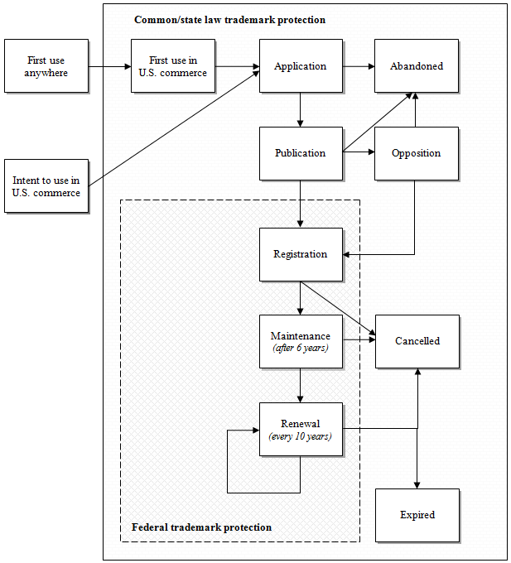
Note: adapted from Graham et al. (2013). For parsimony reasons, some prosecution events are omitted. Under the intent-to-use scenario, no federal registration (and, therefore, protection) is granted until the moment when "(a) the mark is actually used in commerce, (b) a verified statement or declaration to that effect is filed, and (c) a specimen of use is submitted" (Graham et al., 2013:17).
3. Literature review and hypothesis development
3.1. A summary of existing research on trademark value
Most studies that examine the valuation aspect of trademarking are concerned with the effect of new trademark applications/registrations on the firm's market value (see Bosworth and Rogers, 2001; Feeny and Rogers, 2003; Greenhalgh and Rogers, 2006a; 2006b; 2012; Fosfuri and Giarratana, 2009; Krasnikov et al., 2009). This approach is based on the idea that when determining firm value, financial markets take into account the value not only of its tangible but also of its intangible assets, such as R&D expenditure, patents, and trademarks. Therefore, the following valuation function can be derived (Griliches, 1981):
$V=q∙{\left(A+K\right)}^{σ}$,
where $V$ is the firm's market value; $A$ is the value of the firm's tangible assets; $K$ is the value of the firm's intangible (or knowledge-related) assets; $q$ is the market valuation coefficient of the firm's assets that reflects its differential risk and monopoly position; and $σ$ is a parameter that reflects the possibility of non-constant returns to scale.
This approach has been used to reveal significant effects that trademark activities have on firm value. For example, Bosworth and Rogers (2001) showed that in a sample of Australian firms, non-manufacturing companies do benefit from higher trademark intensity in terms of its positive impact on firm value; however, this positive impact disappears when the whole sample is considered. The latter result was corroborated by Feeny and Rogers (2003), who found that the firm value effect of trademark intensity is not statistically different from zero, no matter whether industry controls are included or not. In turn, Greenhalgh and Rogers (2006a) continued with the idea that there should be sectoral disparities in the market valuation of trademarking. They employed U.K. intellectual property statistics and confirmed that a more intensive use of trademarks in services leads to a higher market premium, unlike in transport, communication, utilities, and manufacturing sectors: although trademarking is still popular there, its impact on the value that financial markets place on firms is not statistically significant. Another study by Greenhalgh and Rogers (2006b) pointed out that the intensity of trademark applications filed by U.K. firms positively affects market valuation across (Pavitt) technological sectors, except for the information intensive sector where the effect is negative. Finally, Greenhalgh and Rogers (2012) identified a non-linear relationship between trademark intensity and the market value of a firm, thus indicating diminishing returns from adding an extra mark to the trademark portfolio.
The studies mentioned above, albeit useful for our understanding of the economic effect of trademark activities, are based on a rather restrictive assumption that the trademark flow is homogeneous. In other words, they largely ignore the fact that marks are often interrelated, as well as the fact that some trademarks are likely to be more valuable than others. With respect to the former observation, Sandner (2009:1257) showed that "trademark portfolios are not loose agglomerations of trademarks but, instead, contain complex structures that coherently protect a company's brand, which may extend across multiple products, product categories, and services". A subsequent empirical analysis of trademark families by Block et al. (2014b) confirmed that financial markets also observe these structures and evaluate them differently – they attach greater value to trademarks that ensure the protection of brand extensions than to trademarks that protect newly created brands. Finally, Agostini et al. (2015) revealed that corporate trademarks have a positive effect on firm sales, unlike product marks (whose contribution to sales performance is insignificant).
As for trademarks' own value, Sandner and Block (2011) relied on the patent literature to identify characteristics that might be useful for distinguishing between more valuable and less valuable marks. They looked at such characteristics as (a) trademark breadth, or the number of product classes covered by the trademark; (b) trademark seniority, or the number of trademarks registered in other national jurisdictions; (c) trademark oppositions brought by the mark owner; and also (d) trademark oppositions received by the mark owner. The cross-country analysis they performed suggests that higher returns are associated with more senior marks, as well as with marks for which the owner filed an opposition against another party. The authors thus concluded that "[b]y filing an own trademark or an opposition against a rival's trademark, firms show to the financial markets that they are eager to protect their marketing investments [..., and stock] markets seem to value such activity" (Sandner and Block, 2011:983).
In this study, I somewhat extend Sandner and Block's (2011) approach and propose to view any trademark as a range of distinctive characteristics, each of which contributes towards the owner's perception of its value. However, unlike the above studies, which deduce trademark value from the reaction of financial markets on the owner's attempt to obtain trademark protection, I propose to capture it by focusing on the behaviour of the owner of a trademark at each stage of the trademark lifecycle, consisting of registration, maintenance, and renewal (see Figure 2). An important aspect of engaging with trademark protection at the federal level is that it imposes costs on the trademark owner. Although application and maintenance fees are relatively small, the decision to use this protection is still sensitive to filing fees: for example, it has been noted that the recent trend to reduce these fees has contributed to the growing popularity of trademark protection in various countries (see Herz and Mejer, 2016). The total costs of federal trademark protection are, of course, even higher because they also include the owner's attorney expenses, as well as the costs stemming from its enforcement. At the same time, potential benefits of using the federal system can be substantial, too, largely owing to the fact that the ultimate object of
Figure 2. Trademark characteristics and the trademark protection lifecycle: A conceptual framework
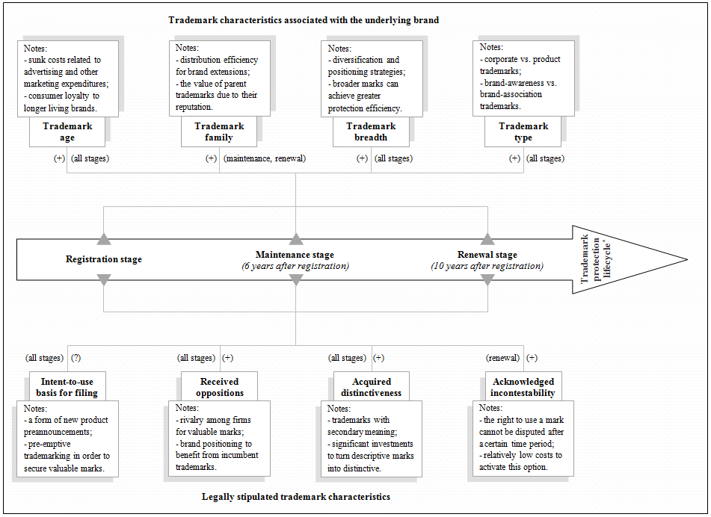
* See Section 2.2 and Figure 1 for a more detailed discussion of the trademark protection lifecycle.

this protection is brand equity (de Rassenfosse, 2017; von Graevenitz, 2013). With this in mind, the owner's decision to turn to and maintain federal protection is thus likely to be guided by whether perceived benefits exceed the actual costs of this protection (Mendonça et al., 2004). In line with this reasoning, I expect that more valuable marks should be protected for a longer period of time than less valuable marks. In what follows, I will identify and review trademark characteristics (related to both trademark law and branding strategy) that may affect the owner's decision first to register the mark and then to maintain its registration.
3.2. Trademark characteristics and their relationship to trademark value
3.2.1. Trademark characteristics associated with the underlying brand. I start hypothesis development by looking at a set of trademark characteristics relevant to branding strategy and, as such, less dependent on a given protection system.
Trademark age. The value effect of trademark ageing can be explained by drawing on two interrelated theoretical perspectives. According to the sunk cost perspective, advertising and other marketing investments aimed at promoting the brand cannot be fully recouped upon the brand's termination (Kessides, 1986; Sutton, 1991). They are nonetheless of great importance not only for developing the firm's competitive advantage, but also for the brand owner's ability to efficiently communicate with customers (Keller and Lehmann, 2006; Krasnikov et al., 2009). Thus, one can expect that the greater the financial resources invested in the brand are, the greater will be the incentive for its owner to keep the brand alive, including its protection in the form of a registered trademark. As long as the cumulative amount of these investments increases, so should the value of the associated trademark, at least for its owner.
In turn, the brand loyalty perspective holds that individual preferences with respect to the brand develop as the brand ages, whether because of marketing activities, positive personal experience, or other similar factors (Aaker, 1991). As a result, older brands tend to enjoy greater customer loyalty than younger brands (Keller, 1999). Since brand loyalty is among the major determinants of firms' market share, the prices they can charge, and their profitability (Aaker, 1992; Chaudhuri and Holbrook, 2001), brand owners are likely to value older – and, hence, better recognised – brands more, which may result, inter alia, in ensuring their continued protection by maintaining active trademark registrations.
Few empirical studies have directly examined trademark age. Jensen and Webster (2008: 138) adopt the brand loyalty perspective to show that "each additional year of existence of a trade mark enhances consumer demand"; yet, they also find diminishing returns to consumer loyalty – these returns require firms to continuously invest in updating their brands in order to compete with new brands entering the market. In turn, following the sunk cost perspective, Melnyk et al. (2014) reveal that, with age, the probability of trademark prolongation increases. Conversely, the study of U.S. commercial banks by González-Pedraz and Mayordomo (2012) demonstrates that to increase market value, companies should maintain a relatively younger stock of living trademarks, while eliminating older trademarks. This finding seems to be at odds with the other two studies, with a possible explanation relating to the peculiarities of the competition through product innovation within the banking sector (see Duygun et al., 2013).
Hypothesis 1: | Older trademarks have greater value, which should be reflected in the duration of their protection.
Trademark family. Sandner (2009) defines a trademark family as a separate, internally coherent group of marks whose function is to jointly protect the underlying brand and preserve its distinctiveness. His analysis of the trademark activities in 4,085 publicly traded corporations shows that trademark families follow one of four filing strategies: creating a new brand, as well as hedging, modernising, or extending the existing brand. In turn, Block et al. (2014b) evaluate the effects of these four strategies on a firm's market value. Their findings suggest that financial markets do place a premium on trademarks, but only when trademarks concern the development of existing brands, whereas there is no evidence of a similar market reaction to newly developed brands. This outcome is generally consistent with the distribution efficiency hypothesis, which states that under certain conditions, firms can economise on product introduction and promotion expenditures by pursuing a brand-extension strategy (Aaker and Keller, 1990; Smith and Park, 1992; Völckner and Sattler, 2006). Financial markets recognise these cost-related advantages and tend to value brand extensions more than single brands (Lane and Jacobson, 1995). Relatedly, owners may also assign greater value to trademarks that protect brand extensions – and, as such, belong to a trademark family – rather than to single trademarks.
An additional comment needs to be made regarding so-called parent brands, which are also a part – perhaps the most important one – of a trademark family. The value of such brands should not be underestimated because they provide the very basis for a brand-extension strategy (Farquhar, 1989; Keller and Aaker, 1992; Keller and Lehmann, 2006). In particular, this strategy is likely to be adopted when a parent brand has a solid reputation for product quality; in this case, the owner may choose to introduce an extension to the parent brand and attach it to a new product to send a credible signal to consumers about the quality of the new product (Wernerfelt, 1988). Having these considerations in mind, the continued protection of parent brands becomes necessary to mitigate the risks of consumer confusion and reputation erosion caused by unfair trade practices.
Hypothesis 2(a): | Trademark extensions have greater value, which should be reflected in a higher probability of their maintenance and renewal.
Hypothesis 2(b): | Parent trademarks have greater value, which should be reflected in a higher probability of their maintenance and renewal.
Trademark breadth. A product class denotes the category of goods or services in which a trademark is used for differentiation purposes. When applying for trademark registration, the owner must specify the product class or classes in which the mark needs federal protection, with their total number often being referred to as trademark breadth (Sandner and Block, 2011). Existing studies construe multiple interclass registrations as a reflection of the diversification and positioning strategies the mark owner is pursuing (see Mendonça et al., 2004; Sandner, 2009; Graham et al., 2013; Block et al., 2014a). More specifically, it is argued that by promoting the same mark in different product markets, the owner thus leverages the brand equity associated with that mark across a portfolio of businesses in order to induce the purchasing behaviour similar to that observed in the original product market (Aaker and Keller, 1990; Choi, 1998; Cabral, 2000). Following this logic, the fact that a trademark spans several product classes points to its greater value for the owner, largely due to the power it possesses in directing consumer demand and, not least, to its potential for enhancing the capability of the trademark owner to compete against incumbent firms (Pepall and Richards, 2002).
Protection-wise, registering a trademark in multiple product classes signals the owner's effort to achieve greater protection efficiency because a "broader trademark portfolio protects multiple facets of a brand in multiple industries, reducing the risk of copying by rivals" (Block et al., 2014a:529). It should be noted that trademark law does not preclude different owners from using the same trademark in different product classes as there is a low likelihood of consumer confusion this case (Shipman, 1998). So, when the owner opts for narrower protection, this can potentially undermine the trademark's image in the original market if that mark is misused by other owners in other product markets.
Similar to findings of Sandner and Block (2011), it can thus be expected that the breadth of trademark protection is positively associated with the owner's valuation of the trademark.
Hypothesis 3: | Trademarks filed in more product classes have greater value, which should be reflected in the duration of their protection.
Trademark type. Two basic approaches can be used to cluster trademarks according to their type. The first approach draws on differences in the brand assets that trademarks protect: on the one hand, there are corporate brands, which represent "the firm that will deliver and stand behind the offering that the customer will buy and use" (Aaker, 2004:6); and on the other hand, trademarks can protect product brands designating a specific product or product line. According to Balmer and Gray (2003), the differences between these brand types stem, inter alia, from the level of responsibility for their management, the length of their gestation, as well as the range of the stakeholders they focus on. Since corporate brands tend to be more of a concern of chief executives, appeal to multiple stakeholders (not only consumers), and are rare because of their complexity and a relatively long gestation (Balmer and Gray, 2003:988), they are expected to be more valuable to their owners than are product brands, and this should be reflected in their greater protection by means of trademarks. In addition, the study by Agostini et al. (2015) demonstrates that corporate trademarks are among the key determinants of firm sales in the Italian fashion industry, unlike product trademarks. The authors' explanation of this finding refers to the product lifecycle: being shorter in creative industries, it motivates firms to concentrate their efforts on building a strong corporate brand instead of developing and promoting many soon-dying product brands, with a corresponding effect on trademark survival.
The second approach is based on examining the content of a trademark, which is also likely to influence trademark valuation. According to U.S. trademark law, the types of things used to depict a trademark can range from plain text to sounds, scents, and even non-visual forms. Depending on the content of their depiction, all trademarks can be grouped into either brand-awareness or brand-association categories (Keller, 1993; 1998; Keller and Lehmann, 2006). As Krasnikov et al. (2009) put it, the purpose of brand-awareness trademarks is to help buyers recognise the underlying brand in the marketplace (crowded as it is with other competing brands); in turn, brand-association trademarks intend to convey the meaning of the brand to consumers and, by doing so, to influence consumers' brand-related attitudes. Empirical studies show that financial markets value these trademark types differently. For example, Krasnikov et al. (2009) reveal that the stock of brand-association trademarks increases the firm's Tobin's q and stock returns, while the stock of brand-awareness trademarks formed by a firm during the previous period significantly reduces the existing positive effect of brand-association trademarks on this firm's value indicators. As the authors explain, "the brand-awareness efforts of firms attract more individual investors to their stocks, thereby attenuating the stock returns and Tobin's q value of such firms" (Krasnikov et al., 2009:163). Having said that, owners may still assign a higher value to brand-awareness trademarks, largely owing to the considerable effect that brand awareness has on consumer choice (Hoyer and Brown, 1990) and its contribution to brand equity (Aaker, 1996).
Hypothesis 4(a): | Corporate trademarks have greater value, which should be reflected in the duration of their protection.
Hypothesis 4(b): | Brand-awareness trademarks have greater value, which should be reflected in the duration of their protection.
3.2.2. Legally stipulated trademark characteristics. In this section, my focus will be on trademark characteristics that are associated with U.S. trademark law, including those derived from the prosecution process.
Intent-to-use legal basis for filing. As U.S. trademark law states, the owner can apply for federal protection some time before the mark's first use in commerce. To proceed with this option, the owner must have a business plan, create sample products, or perform other initial business activities that reflect a bona fide intention to use the mark (USPTO, 2014). Since its inclusion in the legal system in 1988, this option has been very popular among owners, so the majority of all U.S. trademark applications are nowadays filed on the intent-to-use legal basis (Graham et al., 2013).
So, the question arises – why would trademark owners be interested in using this legal option? On the one hand, the owner's attempt to secure the exclusive right to use the trademark before its actual introduction in the market, especially if the mark is valuable, can be viewed as a form of a new product preannouncement (Eliashberg and Robertson, 1988; Lilly and Walters, 1997; Su and Rao, 2010). This strategy can help trademark owners address many critical issues, including minimising the risk of a marketing failure when positioning a new good or service, outperforming rivals in the domain of consumer perception, and also sending a credible signal to external stakeholders about forthcoming product development initiatives. The link between a company's early-stage trademark activities and product preannouncement is supported by the emergence of the so-called submarine trademark filing strategy. This is when a company files "a substantial number of trademark applications in countries [... where trademark applications are not published on-line after filing]; U.S. applicants are still able to claim the priority date of these applications in their subsequent filing with the USPTO" (Fink et al., 2018:343), while avoiding premature product preannouncements that result from trademark applications. Hence, companies that follow this strategy will likely file trademark applications on the intent-to-use legal basis in order to protect more valuable marks.
On the other hand, as von Graevenitz (2013) points out, companies may use trademark protection pre-emptively to prevent valuable trademarks from being appropriated by competitors. A likely strategy in this case would be to file several intent-to-use trademark applications at once, while anticipating that only some – or even one – of them will eventually be used in commerce. According to von Graevenitz (2013), this strategy can be particularly popular in industries with product name regulation, such as the pharmaceutical sector. If adopted, it will result in a pool of substitutable trademarks to register; then, instead of signalling trademark value, this characteristic will capture the owner's brand hedging activities, thereby making it difficult to isolate its link to a trademark's value component. Moreover, new product development may have a negative outcome and, as such, provoke a higher abandonment rate of trademark applications filed on this legal basis, which will further obscure the link between the use of the intent-to-use legal basis for filing a trademark application and the value of the associated trademark.
Overall, while highlighting an association between the legal basis for filing a trademark application and trademark value, I will leave it to the empirical analysis to inform us about its direction, should this association be statistically significant.
Hypothesis 5: | There is an association between the legal basis for filing a trademark application and trademark value, which should be reflected in the duration of trademark protection.
Received oppositions. The primary function of trademarks is to distinguish the output of different parties. To be able to fulfil this function, a trademark should be unique, such that only the definitive association can be established between it and the producer or the product to which it is affixed (Landes and Posner, 1987; Economides, 1988). Hence, introducing a new mark which is highly similar to an incumbent mark may be regarded as trademark infringement because this action may result in a loss of distinctiveness of the incumbent mark and, as such, increase the likelihood of consumer confusion (Cohen, 1986). Unfair trade practices that lead to a trademark losing its distinctiveness are usually considered within the doctrine of trademark dilution: by recognising that brand equity is a valuable asset, the doctrine guarantees protection from an unauthorised commercial use causing its dilution (Klieger, 1996; Peterson et al., 1999). Trademark owners often invoke this instrument to protect their trademarks against infringement: for example, "in McDonald's Corp. v. McBagels, Inc., [...] McDonald's were successful in their defence of the Mc trademark and McBagels were prevented from using it as a name" (Coulthard et al., 2016:3; for more cases, see Heald and Brauneis, 2010).
So, why would one party attempt to dilute the incumbent trademark of another party? There are a number of reasons for trademark dilution to occur. First of all, as the pool of marks continues to grow, greater effort is required to avoid similarities between newly designed and currently used marks. In such industries as pharmaceuticals, where the use of product names is regulated externally, the domain of names to draw from is even narrower (von Graevenitz, 2013), which accentuates the problem (this may lead to medication errors due to confusion over drug names). Finally, from the brand positioning perspective, introducing a trademark which is similar to that of another owner in the same market can be part of a strategy that aims to induce spillover effects associated with the reputation and demand-directing capabilities of the incumbent mark (Semadeni, 2006).
If a third party holds a strong belief that registering a new trademark will increase the likelihood of consumer confusion and, therefore, cause it substantial damages, including "the potentially unfair appropriation of [... its] trademark's value or the possibility of competitors obtaining new trademarks for branding and market entry" (Sandner and Block, 2011:974), this party can institute an opposition proceeding against granting federal protection to the new mark. As von Graevenitz (2009:1) puts it, in order for trademarks to be an effective legal instrument, they must be defended against imitation, with trademark opposition providing "a first line of defence for owners of established brands". Upon successfully overcoming the opposition, the attacked mark moves to the registration stage, otherwise it is deemed to have been abandoned.
Based on these arguments, one can conclude that receiving an opposition to trademark registration should be regarded as an external endorsement of the value that the attacked mark possesses, with the value being derived from the mark's association with established brands. In turn, owners are likely to attach greater value to trademarks that have survived the opposition process and, hence, will opt to ensure their continued protection.
Hypothesis 6: | Trademarks that received oppositions have greater value, which should be reflected in the duration of their protection.
Acquired distinctiveness. Following the discussion in Section 2.1, not all trademarks are subject to federal protection. Yet, unlike generic terms, which must be available for universal use, trademarks relying on descriptive terms can still enjoy full protection if they have acquired sufficient distinctiveness (Linford, 2015b). This is commonly referred to as achieving secondary meaning, or "the fact that the mark has a new meaning rather than the older (primary) meaning" so that consumers can reliably identify – by establishing a mental association – the source of a product with which this mark is used (Cohen, 1986:63). For instance, ALL-BRAN, HOLIDAY INN, WINDOWS are all examples of descriptive marks that have acquired secondary meaning and, thus, have become eligible for trademark protection (Landes and Posner, 1987; Petty, 2008).
U.S. trademark law offers mark owners many options to prove that a mark has acquired secondary meaning, such as demonstrating extensive promotion and distribution expenditures, confirming exclusive commercial use of the mark for at least five years, or providing results of consumer surveys supported by expert testimonies (Cohen, 1986). Because of the significant investments required to turn descriptive trademarks into distinctive ones, their owners are likely to value such trademarks more, with a corresponding positive effect on the duration of their legal protection.
Hypothesis 7: | Trademarks with acquired distinctiveness have greater value, which should be reflected in the duration of their protection.
Acknowledged incontestability. The doctrine of trademark incontestability asserts that the right to use a mark cannot be disputed after some fixed period of time (Christensen, 1966; Port, 1993). According to U.S. trademark law, the continuous use of a mark for five consecutive years after the registration date – together with satisfying other legal requirements – gives its owner an opportunity to request the incontestable status for it. "Once a trademark registration becomes incontestable, the validity of the mark, the validity of the owner's ownership of the mark, and the owner's exclusive right to use the mark on designated goods may be challenged only on [... a limited number of] grounds", most notably those related to how the mark is used in commerce (Port, 1993:535). Almost every registration complying with the basic legal criteria can be granted the incontestable status without the need to provide any formal proof. In fact, approximately 75% of all eligible U.S. trademark registrations have had their incontestability acknowledged by the USPTO (Graham et al., 2013). Among the reasons for such high interest in leveraging this provision is that the costs of obtaining the incontestability status are relatively low, especially compared with the benefits stemming from lower litigation risks. Moreover, as the corresponding affidavit needs to be filed only once, the longer the period of the trademark's commercial use, the less is the per year cost of enforcing this provision.
Hypothesis 8: | Trademarks with acknowledged incontestability have greater value, which should be reflected in a higher probability of their renewal.
4. Empirical setting, data, and methods
4.1. The focal industry
To test the study hypotheses, I have decided to examine trademark activities in the U.S. pharmaceutical industry. This decision is motivated by a number of reasons, including the fact that the competition among drug producers is largely driven by product differentiation forces. In this respect, Chudnovsky (1983:190) correctly points out that "[a]s the choice of the product to be consumed is usually made by the doctor, the demand for drugs and its structure is thus created by the prescriber rather than by the actual consumer. Doctors hardly pay any attention to the prices of the drugs when prescribing and, therefore, the link between price and demand is broken". Being well aware of this situation, pharmaceutical firms tend to invest a significant amount of financial resources in order not only to increase brand awareness among the general public, but also to influence doctors' choice of brands. In such a setting, trademarks appear to be among few instruments for drug producers to secure their investments.
Although there is a widely shared opinion that the pool of words and symbols from which firms can draw to create new brand names is unlimited (Landes and Posner, 1987), this is not quite true for pharmaceutical firms. On the one hand, they seek to establish a close association between the product they are offering and the chemical compound by carefully selecting a drug name, especially when there are competing products in the generic drug market. On the other hand, the U.S. Food and Drug Administration (FDA) regulates drug names in order to prevent (or, at least, to minimise) potential medication errors. Given the costs of devising a new drug name – they reportedly range from USD 75,000 to USD 2.25m (see Kenagy and Stein, 2001; Wick, 2011; Tirrell et al., 2015), – drug producers attempt to secure their right to use the name exclusively before submitting it for an FDA approval, thus inducing a higher trademark intensity and sometimes even causing trademark registers to clutter with unused or overly broad marks (von Graevenitz, 2013).
Finally, the legal protection of drug names is vital for the successful execution of a value transference strategy the purpose of which is to shift "the advantages of technical or performance-based customer benefits (originally reserved in patents or copyrights) to trademarks" (Conley et al., 2013:104; Thoma, 2015; 2019). A good example of how this strategy helps firms secure their competitive edge despite patent expiration is AstraZeneca's campaign for Prilosec, a popular drug for treating indigestion and heartburn problems. According to Conley et al. (2013), the company managed to reinforce its marketing strategy of promoting the product's distinctive features, such as "purple pill", with a range of trademark registrations covering these features. Consequently, AstraZeneca was able to protect its unique selling position and, more importantly, to maintain revenues even when generic drug manufacturers entered the market.
Having these observations in mind and also taking into account the protection lifecycle of trademarks, I argue that pharmaceutical firms, with their heavy reliance on brand names to compete in the marketplace, have sufficient motivation for first applying for, then maintaining, and finally renewing valuable trademark registrations – or, in other words, stretching the protection of the associated brands over a long period of time.
4.2. Data sources and the sample
The sample used in this study consists of 94 U.S. pharmaceutical firms, each of which had at least one trademark registered with the USPTO in the period 1990–2003. The lower bound of this period is set to minimise the likely influence of the 1988/1989 change in U.S. trademark law (see Section 2); in turn, the upper bound enables me to capture more accurately the ten-year renewal event for trademarks registered in 2003 (which will be the year of 2013). To construct the data panel, I adopted the following procedure. First, I identified pharmaceutical companies in the Compustat dataset by searching for the SIC code 2830, including its subcategories. I was particularly interested in companies that had financial data available for the entire period of analysis. Second, I drew on the 2015 release of the USPTO Trademark Case Files dataset to obtain trademark statistics (for more information on the variables available in this dataset, see Graham et al., 2013). For each company in my sample I identified a unique part of its name and then searched the entire trademark dataset for potential matches. Overall, I was able to identify 8,911 trademark applications, of which 3,515 were registered, 1,738 were maintained, and 1,228 were renewed (a detailed overview of the sample is given in Online Appendix A).
4.3. The definitions and measurements of variables
4.3.1. Dependent variables. To capture the outcome of a firm's decision making-process at different stages of the trademark protection lifecycle, I created three dependent variables. Trademark registration is a dummy variable that takes the value of unity if the trademark was registered with the USPTO, and zero otherwise. Trademark maintenance is a dummy variable that takes the value of unity if the trademark registration is not cancelled yet or the difference between cancellation and registration dates is greater than seven years. Trademark renewal is a dummy variable that takes the value of unity if the trademark registration has a renewal date greater than zero.
4.3.2. Independent variables. I shall begin the description of independent variables by looking at trademark characteristics associated with the underlying brand. First, I calculated trademark age by subtracting the date when the trademark was first used in commerce from the event (application, maintenance, or renewal) date. To trace the relationships between marks within a trademark family, I created the following variables: (i) trademark extension is a dummy variable that takes the value of unity if the mark gives at least one citation to other marks; and (ii) parent trademark is a dummy variable that takes the value of unity if the mark only receives citations from other marks, but does not give any citations to other marks. It should be noted that both variables may be biased because "it is not mandatory for applicants to list prior registrations" (Graham et al., 2013:65). Next, I assessed trademark breadth by counting the number of unique NICE classes covered by the mark. I also included two generic trademark types: on the one hand, I followed Agostini et al. (2015) and labelled trademarks that contain the owner's name or its abbreviation as corporate trademarks; on the other hand, similarly to Melnyk et al. (2014), I coded as brand-awareness trademarks those marks that contain standard character drawings. Finally, I added the service mark dummy to account for peculiarities pertaining to this trademark type (see Castaldi, 2018). Although I have not developed any specific set of arguments regarding value discrepancies that exist between trade and service marks, this variable helps me capture a supposedly lesser importance assigned to service marks by the companies operating outside service industries (see Block et al., 2015; Gotsch and Hipp, 2012).
As for legally stipulated trademark characteristics, I created the intent-to-use legal basis for filing dummy pointing to trademarks that were yet to establish their commercial use at the moment of application. To determine if the mark was subject to opposition during the prosecution process, I designed the received oppositions dummy, which refers to marks with an opposition first instituted and then sustained or dismissed (the latter also covers the cases that were settled without any final decision on the merits; see Graham et al., 2013). I then also captured acquired distinctiveness by a dummy variable that equals unity if the trademark has acquired "secondary meaning", even partially, among consumers. Finally, I added the acknowledged incontestability dummy in order to identify the marks for which the owner applied for and received an approval concerning their incontestability status.
4.3.3. Control variables. When selecting firm-level controls, I drew on prior studies that utilised patent and trademark statistics. First, I included company size, measured by the natural logarithm of the total number of employees, to control for differences in resource availability and the costs of generating new intellectual property rights between large and small companies (see Block et al., 2015; Hall and Ziedonis, 2001). Next, I captured a firm's financial performance by using book leverage: it equals the ratio of long-term debt plus current liabilities to total assets. To account for its market performance, I used Tobin's q, defined as the sum of total assets plus the difference between the market and the book value of equity divided by total assets. The both variables were added to control for the financial impact of branding activities on firm value, as well as the availability of resources at a firm's disposal to develop and trademark new products (see Krasnikov et al., 2009; Sandner and Block, 2011). Finally, by including two further variables, R&D intensity (the ratio of a firm's R&D expenditure to total assets) and advertising intensity (the ratio of a firm's advertising expenditure to total sales), I took into account the allocation of resources between two key inputs of trademarking (see Krasnikov et al., 2009; Block et al., 2015).
4.4. Econometric strategy
All the dependent variables that I use in this study are set up as a 0–1 dummy variable. Therefore, as the baseline model, I will run a probit estimation (see Greene, 2003; Wooldridge, 2010), which relates the probability of a trademark being registered, maintained, or renewed to the trademark's characteristics, while also controlling for company- and year-specific effects. The structure of this model type is such that "[t]here is a latent variable y = X'β + e, where X' is an n×k vector of the k covariates and n observations, β is the k×1 vector of parameters to be estimated, and e is the n×1 vector of i.i.d. normally distributed errors". Since the latent variable is not directly observable, it can be estimated as:
$$Prob\left(y_{i}=1\right)≡Φ\left(ε_{i}<x_{i}^{'}β\right),$$
where ε_{i} is the ith observation of e, x'_{i} is the ith row of X', Φ is the standard normal distribution, and the vector β is normalised by the standard error of e (adapted from Gambardella et al., 2007: 1174).
Hence, the probability that a mark is, for example, protected at the federal level (that is, it is registered with the USPTO) can be expressed by the following equation:
$\operatorname{Prob}\left(y_{ij}=1\right)=f\left(α+\sum_{k=1}^{11}{β_{k}x_{ij,k}}+\sum_{m=1}^{5}{δ_{m}q_{j,m}}+μ_{t}\right)$,
where $y_{ij}$ is a dummy variable that takes the value of unity if Firm j was granted registration of its Trademark i; $α$ is the constant term; $x_{ij,k}$ is the vector of trademark-specific characteristics (k = 1, ..., 11); $q_{jt,m}$ is the vector of company-specific control variables (m = 1, ..., 5); and $μ_{t}$ is a year-specific effect (based on the filing year for trademark registration, and the registration year for trademark maintenance and renewal).
This model is used to derive some initial results before more elaborate models and model specifications are used, such as (see Sections 5.2 and 5.3): an ordered probit model; a logit model to base estimations on a different assumption regarding the distribution of the error term (the distribution is logistic in a logit model and normal in a probit model; see Wooldridge, 2010); a probit model with clustered standard errors at the firm level in order to account for unobserved correlation among the error terms of the trademarks owned by the same firm; a probit model with firm dummies to account for firm fixed effects; and a Heckman selection probit model (see Heckman, 1976; 1979) to account for potential interdependencies between different stages of the trademark protection lifecycle.
5. Results and analysis
5.1. Descriptive results
Tables 1 and 2 show descriptive statistics and the correlation matrix for study variables, respectively.
In particular, Table 1 suggests that 36% of all trademark applications eventually proceed to the registration stage; 54% of the registered trademarks overcome the sixth-year maintenance event; and 71% of maintained marks are renewed after the first ten-year term. At the time of filing an application with the USPTO, the average mark has already been used in commerce for about one year. Interestingly, both parent marks and trademark extensions move further along the trademark protection lifecycle, which is evident from the corresponding means increasing from registration to maintenance, and from maintenance to renewal. The absolute majority of the trademarks, regardless of the stage of the lifecycle, belong to the brand-awareness type and cover only one product class. Almost 1% of the trademarks in the full sample are classified as corporate, but their share has a tendency to grow at maintenance and renewal stages. In turn, the proportion of service marks is fairly stable at around the 10% level.
Turning to legally stipulated trademark characteristics, intent-to-use is the most popular legal basis for filing a trademark application. However, applications filed on this legal basis also have higher abandonment rates: for example, only 53% of all trademarks have this status at the maintenance stage, compared with 80% at the application stage. In contrast, trademark opposition is a rare event, with only approximately 2 out of 100 marks having been subject to opposition proceedings. Similarly, less than 3% of the sampled marks (depending on stage of the lifecycle) have acquired distinctiveness among consumers as a source identifier for a product or service. Finally, roughly 50% of the maintained marks have been granted the incontestability status, and the share of these marks reaches 93% at the renewal stage.
Table 1. Descriptive statistics
No. | Variable | Trademark  registration |  | Trademark  maintenance |  | Trademark  renewal
 |  | Mean | Std. dev. | Mean | Std. dev. | Mean | Std. dev.
1 | Trademark registration | 0.360 | 0.480
2 | Trademark maintenance |  |  | 0.537 | 0.499
3 | Trademark renewal |  |  |  |  | 0.707 | 0.455
4 | Trademark age | 0.871 | 4.835 | 10.302 | 7.617 | 14.283 | 9.218
5 | Trademark extension | 0.155 | 0.362 | 0.251 | 0.434 | 0.280 | 0.449
6 | Parent trademark | 0.055 | 0.227 | 0.153 | 0.360 | 0.208 | 0.406
7 | Trademark breadth | 1.110 | 0.471 | 1.107 | 0.453 | 1.105 | 0.500
8 | Corporate trademark | 0.008 | 0.088 | 0.020 | 0.141 | 0.032 | 0.177
9 | Brand-awareness trademark | 0.844 | 0.363 | 0.765 | 0.424 | 0.785 | 0.411
10 | Service mark | 0.090 | 0.287 | 0.117 | 0.321 | 0.085 | 0.279
11 | Intent-to-use legal basis for filing | 0.826 | 0.379 | 0.539 | 0.499 | 0.532 | 0.499
12 | Received oppositions | 0.023 | 0.150 | 0.013 | 0.111 | 0.019 | 0.137
13 | Acquired distinctiveness | 0.009 | 0.097 | 0.023 | 0.151 | 0.026 | 0.161
14 | Acknowledged incontestability | 0.183 | 0.386 | 0.496 | 0.500 | 0.926 | 0.262
15 | Company size | 9.611 | 2.163 | 9.722 | 2.195 | 9.659 | 2.247
16 | Book leverage | 0.189 | 0.204 | 0.226 | 1.283 | 0.226 | 0.581
17 | Tobin's q | 4.452 | 2.679 | 3.314 | 2.575 | 2.923 | 2.224
18 | R&D intensity | 0.111 | 0.129 | 0.097 | 0.201 | 0.104 | 0.327
19 | Advertising intensity | 0.037 | 0.045 | 0.030 | 0.043 | 0.024 | 0.032
Number of observations |  | 8,911 |  | 3,515 |  | 1,738
The table presents descriptive statistics for three subsamples: (i) the registration subsample covers both successful and unsuccessful trademark applications; (ii) the maintenance subsample contains trademark registrations that survived the hazard of six-year maintenance, as well as cancelled trademark registrations; and (iii) the renewal subsample includes trademark registrations that were renewed after the first ten-year period and also expired trademark registrations.

Table 2. Correlation matrix
No. | Variable | 1 | 2 | 3 | 4 | 5 | 6 | 7 | 8 | 9 | 10 | 11 | 12 | 13 | 14 | 15 | 16 | 17 | 18 | 19 | VIF
1 | Trademark registration | 1.00 |  |  |  |  |  |  |  |  |  |  |  |  |  |  |  |  |  |  | -
2 | Trademark maintenance | -0.59* | 1.00 |  |  |  |  |  |  |  |  |  |  |  |  |  |  |  |  |  | -
3 | Trademark renewal | 0.53* | 0.17* | 1.00 |  |  |  |  |  |  |  |  |  |  |  |  |  |  |  |  | -
4 | Trademark age† | 0.20* | -0.04* | 0.20* | 1.00 |  |  |  |  |  |  |  |  |  |  |  |  |  |  |  | 1.20
5 | Trademark extension | 0.20* | -0.07* | 0.13* | 0.12* | 1.00 |  |  |  |  |  |  |  |  |  |  |  |  |  |  | 1.14
6 | Parent trademark | 0.32* | -0.07* | 0.31* | 0.01 | -0.10* | 1.00 |  |  |  |  |  |  |  |  |  |  |  |  |  | 1.09
7 | Trademark breadth | -0.00 | -0.00 | -0.01 | 0.02* | 0.05* | 0.01 | 1.00 |  |  |  |  |  |  |  |  |  |  |  |  | 1.02
8 | Corporate trademark | 0.08* | 0.02* | 0.13* | 0.12* | 0.10* | 0.07* | 0.06* | 1.00 |  |  |  |  |  |  |  |  |  |  |  | 1.05
9 | Brand-awareness trademark | -0.18* | 0.13* | -0.05* | -0.04* | -0.17* | -0.02 | -0.09* | -0.05* | 1.00 |  |  |  |  |  |  |  |  |  |  | 1.07
10 | Service mark | 0.09* | -0.12* | -0.03* | -0.01 | -0.01 | 0.01 | -0.00 | 0.02 | -0.09* | 1.00 |  |  |  |  |  |  |  |  |  | 1.04
11 | Intent-to-use legal basis for filing | -0.47* | 0.27* | -0.27* | -0.38* | -0.14* | -0.10* | -0.02 | -0.09* | 0.20* | -0.13* | 1.00 |  |  |  |  |  |  |  |  | 1.31
12 | Received oppositions | -0.06* | 0.05* | -0.01 | -0.02 | -0.03* | -0.02* | -0.02 | -0.01 | 0.02* | -0.04* | 0.03* | 1.00 |  |  |  |  |  |  |  | 1.01
13 | Acquired distinctiveness | 0.09* | -0.04* | 0.05* | 0.14* | 0.10* | -0.01 | -0.01 | 0.02 | -0.07* | 0.01 | -0.15* | -0.02 | 1.00 |  |  |  |  |  |  | 1.04
14 | Acknowledged incontestability | 0.63* | 0.21* | 0.79* | 0.20* | 0.18* | 0.30* | 0.00 | 0.12* | -0.08* | -0.02 | -0.30* | -0.02* | 0.07* | 1.00 |  |  |  |  |  | 1.04
15 | Company size† | -0.07* | -0.01 | -0.09* | -0.03* | 0.03* | -0.04* | -0.01 | -0.13* | -0.02* | 0.01 | 0.07* | -0.07* | 0.03* | -0.08* | 1.00 |  |  |  |  | 1.18
16 | Book leverage† | -0.03* | 0.02* | 0.01 | -0.00 | -0.00 | -0.01 | 0.01 | -0.01 | 0.00 | -0.01 | 0.02 | -0.00 | -0.01 | -0.00 | -0.02 | 1.00 |  |  |  | 1.02
17 | Tobin's q† | -0.11* | 0.05* | -0.07* | -0.05* | -0.04* | 0.00 | -0.04* | -0.01 | 0.05* | 0.03* | 0.11* | 0.00 | -0.01 | -0.07* | -0.05* | 0.05* | 1.00 |  |  | 1.47
18 | R&D intensity† | -0.04* | 0.03* | -0.01 | -0.03* | -0.01 | 0.04* | -0.01 | 0.10* | 0.02 | 0.01 | 0.06* | 0.02* | 0.01 | -0.02* | -0.28* | 0.04* | 0.36* | 1.00 |  | 1.30
19 | Advertising intensity† | 0.02 | -0.03* | -0.03* | 0.01 | 0.06* | 0.00 | -0.03* | -0.03* | -0.03* | 0.00 | -0.00 | -0.03* | 0.01 | -0.01 | 0.19* | -0.00 | -0.00 | -0.09* | 1.00 | 1.08
The table presents Pearson's pairwise correlations. The results are based on the registration subsample that covers both successful and unsuccessful trademark application. The dagger (†) denotes variables measured at the filing year. The asterisk (*) denotes correlation coefficients significant at the 5% level or better. VIF is the variance inflation factor calculated for each independent variable based on Model 1 in Table 3 (Model 2 is used for VIFs concerning trademark family – trademarks extensions and parent trademarks, while Model 3 is used for acknowledged incontestability).

To confirm that multicollinearity does not pose a problem to my analysis, I calculated the variance inflation factor (VIF) for each independent variable in the baseline specification (Model 1 in Table 3). The results of this test (see Table 2) revealed no serious problems because all the VIFs turn out to be significantly smaller than 10 – the threshold imposed by the general rule of thumb.
5.2. Trademark characteristics and the continuity of trademark protection
Table 3 presents the results of the empirical analysis linking trademark characteristics to the continuity of trademark protection. The overall conclusion to draw from this analysis is that both brand- and law-related characteristics tend to be important predictors of the probability of a trademark moving from one stage of its protection lifecycle to another. Since the decision to keep the trademark protected is costly (therefore, at each point of time the mark owner should decide if the expected benefits of trademark protection are at least as high as its actual costs), the trademark characteristics identified above are also likely to reflect trademark value, at least as perceived by the trademark owner. However, my results suggest that one has to be conscious of how to interpret value-related aspects of trademark characteristics because the interpretation sometimes depends on the stage of the trademark protection lifecycle.
In particular, my findings demonstrate that older trademarks are likely to be registered and maintained; however, unlike what was expected, this characteristic has limited applicability, which is evident from its statistically insignificant association with the owner's decision to renew a trademark (Hypothesis 1 is partially supported). To ease the interpretation of these and other findings, I have computed marginal effects: they show that, with all other factors held constant, an extra year added to the mark's age corresponds to a 0.6% (p < 0.01) increase in the probability of its registration, as well as to a 0.8% (p < 0.001) increase in the probability of its maintenance. The findings for trademark renewals do not support the trademark elimination strategy observed by González-Pedraz and Mayordomo (2012) because trademark age is not a significant factor in
Table 3. Trademark characteristics and the continuity of trademark protection:
Probit models
Independent variables | Trademark  registration |  | Trademark  maintenance |  | Trademark  renewal
 | Model 1 | dx/dy | Model 2 | dx/dy | Model 3 | dx/dy
Trademark age _{i,j,t} | 0.017** | 0.006** | 0.021*** | 0.008*** | 0.004 | 0.001
 | (0.006) | (0.002) | (0.005) | (0.002) | (0.003) | (0.001)
Trademark extension _{i,j} |  |  | 0.342*** | 0.136*** | -0.013 | -0.004
 |  |  | (0.054) | (0.021) | (0.080) | (0.027)
Parent trademark _{i,j} |  |  | 0.692*** | 0.275*** | 0.367*** | 0.122***
 |  |  | (0.065) | (0.026) | (0.091) | (0.030)
Trademark breadth _{i,j} | -0.003 | -0.001 | -0.019 | -0.008 | -0.077 | -0.026
 | (0.034) | (0.012) | (0.049) | (0.019) | (0.064) | (0.021)
Corporate trademark _{i,j} | 0.595** | 0.229** | 0.712*** | 0.253*** | 0.821*** | 0.200***
 | (0.200) | (0.079) | (0.215) | (0.062) | (0.235) | (0.037)
Brand-awareness trademark _{i,j} | -0.409*** | -0.152*** | 0.123* | 0.049* | 0.292*** | 0.101***
 | (0.047) | (0.018) | (0.053) | (0.021) | (0.082) | (0.030)
Service mark _{i,j} | 0.131* | 0.047* | -0.400*** | -0.158*** | -0.515*** | -0.189***
 | (0.057) | (0.021) | (0.070) | (0.027) | (0.116) | (0.045)
Intent-to-use legal basis for filing _{i,j} | -1.465*** | -0.536*** | 0.055 | 0.022 | -0.089 | -0.030
 | (0.050) | (0.016) | (0.052) | (0.021) | (0.078) | (0.026)
Received oppositions _{i,j} | -0.682*** | -0.192*** | 0.573* | 0.210* | -0.090 | -0.031
 | (0.122) | (0.025) | (0.230) | (0.073) | (0.239) | (0.083)
Acquired distinctiveness _{i,j} | 0.271 | 0.101 | 0.014 | 0.006 | 0.136 | 0.043
 | (0.214) | (0.083) | (0.153) | (0.060) | (0.215) | (0.065)
Acknowledged incontestability _{i,j} |  |  |  |  | 0.747*** | 0.280***
 |  |  |  |  | (0.126) | (0.049)
Company size _{j,t} | -0.021** | -0.008** | -0.049*** | -0.019*** | -0.027 | -0.009
 | (0.008) | (0.003) | (0.011) | (0.004) | (0.016) | (0.005)
Book leverage _{j,t} | 0.053 | 0.019 | -0.157 | -0.062 | -0.274** | -0.091**
 | (0.119) | (0.042) | (0.113) | (0.045) | (0.089) | (0.030)
Tobin's q _{j,t} | -0.036*** | -0.013*** | 0.003 | 0.001 | 0.048† | 0.016†
 | (0.008) | (0.003) | (0.012) | (0.005) | (0.026) | (0.009)
R&D intensity _{j,t} | 0.035 | 0.012 | -0.030 | -0.012 | -0.114 | -0.038
 | (0.151) | (0.053) | (0.186) | (0.074) | (0.118) | (0.039)
Advertising intensity _{j,t} | 0.458 | 0.161 | -1.952*** | -0.774*** | -0.268 | -0.089
 | (0.344) | (0.121) | (0.569) | (0.226) | (1.017) | (0.338)
Year fixed effects | Yes |  | Yes |  | Yes
Number of observations | 8,911 |  | 3,515 |  | 1,738
Number of companies | 94 |  | 88 |  | 77
Log likelihood | -4,299.9 |  | -2,250.0 |  | -955.1
Pseudo R² | 0.261 |  | 0.073 |  | 0.092
† 10% significance; * 5% significance; ** 1% significance; *** 0.1% significance.
The table reports the estimation results of random effects probit and ordered probit models. The dependent variable in Model 1 is a dummy variable that takes the value of unity if the trademark was registered. The dependent variable in Model 2 is a dummy variable that takes the value of unity if the trademark was maintained. The dependent variable in Model 3 is a dummy variable that takes the value of unity is the trademark was renewed. dy/dx columns show marginal effects at the mean. Standard errors corrected for heteroskedasticity by using the White-Huber method are in italics. Intercepts are included but not reported. Sources and variable definitions are given in Table B.1 in Online Appendix B.

the trademark renewal decision. In the context of the value transference strategy (see Conley et al., 2013; Thoma, 2015; 2019), this finding may also reflect the chronological boundaries within which pharmaceutical firms operate when transferring the value from patents to trademarks.
Next, trademarks that belong to a trademark family tend to be protected for longer. As my results reveal, trademark extensions are valued at the maintenance stage – there is a 13.6% increase (p < 0.001) in the probability of their maintenance; at the same time, they are neither more nor less likely to be renewed (Hypothesis 2a is only partially supported). These results may suggest that the distribution efficiency associated with trademark extensions is of lesser concern for trademark owners when such marks move further along their lifecycle. In turn, parent marks are particularly valuable – they have 27.5% (p < 0.001) more chances of being maintained, and 12.2% (p < 0.001) more chances of being renewed, largely because such trademarks form the basis of the brand-extension strategy (Keller and Aaker, 1992) and, thus, have to be continuously protected (Hypothesis 2b is supported).
Turning to trademark types, corporate marks are valued more than non-corporate marks, which is evident from the positive association they have with the probability of legal protection at every stage of the trademark lifecycle (Hypothesis 4a is supported): these trademarks have a 20-25% (p < 0.001) higher chance of being registered, maintained, and renewed. The results are consistent with the study by Agostini et al. (2015), whose reasoning draws on the fact that corporate brands are often longer-living and, as such, require ongoing protection of their value (formed via advertising investment) from potential mis-appropriation by a third party, which in this case could be detrimental for the reputation of the entire company.
Interestingly, I have also found that the effect of some brand-related characteristics on the probability of trademark protection depends on the stage of the trademark lifecycle under consideration. This is particularly true for brand-awareness trademarks – they show a positive association with the continuity of trademark protection for the post-registration period, whereas the chances of their registration are 15.2% (p < 0.001) lower compared with other mark types (Hypothesis 4b is partially supported). These results effectively suggest that once registered, brand-awareness marks become more valuable to their owners because they not only "enable consumer recognition of brands in the crowded marketplace [..., but also] serve as important predictive cues of product performance to consumers" (Krasnikov et al., 2009:156).
Another characteristic that generates mixed results is the service mark type: evidently, service marks have a 4.7% (p < 0.05) higher probability of being registered, while a 16-19% (p < 0.001) lower probability of being maintained and renewed. One possible explanation of the observed effect is that services may have a shorter lifecycle, so the changes in the sign of this indicator do not necessarily reflect value discrepancies between product and service marks, at least at later stages of the protection lifecycle. My data particularly show that of all the registered service marks, only 37.8% are maintained after the first six-year period, when confirming that the mark is still in commercial use is essential; this is in contrast to product marks, with 56.2% of them surviving the maintenance period. In addition, Flikkema et al. (2019:4) note that "firms often struggle with up-scaling new services [...] because service innovation is frequently an ad hoc process", which, inter alia, may result in a higher cancellation rate for service marks.
Regarding law-related characteristics, I first focus on the intent-to-use applications: they are 53.6% (p < 0.001) less likely to pass the registration stage than actual use applications, thus making this characteristic the strongest predictor of trademark registrations (Hypothesis 5 is supported). The observed result may suggest that the decision of the mark owner to apply for federal protection before the mark has actually entered the marketplace does not reflect its value, especially considering that this legal basis for filing has no statistically significant effect on the probability of trademark maintenance and renewal. Instead, this characteristic may capture the extent of pre-emptive trademarking (see von Graevenitz, 2013).
Turning to the marks that were subject to an opposition proceeding, they have a 19.2% (p < 0.001) lower probability of being registered; however, upon surviving the opposition event, they are 21.0% (p < 0.05) more likely to be maintained (Hypothesis 6 is partially supported). This characteristic may, therefore, be viewed as a value indicator only for registered trademarks during the maintenance period, after which it has no influence on the owner's decision to renew a mark – the latter is evident from its insignificant association with trademark renewals. The fact that trademark applications subject to opposition are likely to be withdrawn or abandoned might reflect the difficulties with overcoming the barriers that the trademark protection system sets for firms willing to capitalise on reputation spillovers from incumbent trademarks (Semadeni, 2006). At the same time, should such trademarks be granted federal protection, their owners value them more and ensure their protection, at least for the initial six years.
Obtaining the incontestability status may also signal that the owner values the mark for which this status was granted more, since it is 28.0% (p < 0.001) more likely that the protection of incontestable trademarks goes beyond the first ten-year period (Hypothesis 8 is supported). To recall, having trademark incontestability acknowledged significantly reduces the number of reasons for which the trademark registration can be challenged by a third party (Port, 1993). This status can be obtained after the continuous use of a mark for five consecutive years after the registration date. So, despite clear value implications, its use is limited to trademark renewals. As my data show, only around 14.0% of all trademark applications actually reach and overcome the renewal stage, and for the rest this indicator is unavailable.
Finally, it should be noted that my analysis has failed to identify any significant effects that would be associated with trademark breadth or acquired distinctiveness (Hypotheses 3 and 7 are not supported). I believe that this is due to the idiosyncrasy of trademark activities in the pharmaceutical industry. Firstly, the absolute majority of trademarks filed by the firms in my sample cover only one product class (see Figure A.4 in Online Appendix A), thus reducing the ability of this characteristic to differentiate valuable trademarks from the rest. Secondly, as far as acquired distinctiveness is concerned, the overreliance of pharmaceutical firms on drug names may preclude them from waiting for a valuable name to achieve secondary meaning; moreover, the regulation of drug names by the FDA may also make it difficult to adopt this strategy.
5.3. Model extensions and robustness checks
The stages of the trademark protection lifecycle can also be represented by a categorical ordinal variable that takes the value of 1 when the mark is registered, 2 when it is maintained after the six-year period, and 3 when it is renewed after the ten-year period. Therefore, I have re-estimated the baseline specification by using the ordered probit model which is designed to handle ordinal dependent variables (see Greene, 2003). The results of this analysis are largely in line with what I observed when I examined each stage separately (see Table 4). Specifically, trademark age, being a parent trademark, a trademark extension, or a corporate mark – all still have a positive association with continued trademark protection and, hence, trademark value. However, being a brand-awareness mark or having an opposition proceeding instituted seems to distinguish valuable marks only once they have been registered. Conversely, trademark breadth (unlike what I observed in the baseline models, though the effect is only marginally significant), being a service mark, and also the intent-to-use legal basis for filing show a negative association with continued trademark protection, with the latter two, as discussed above, not necessarily reflecting the mark's value. It should further be noted that I have excluded the acknowledged incontestability dummy from Models 4 and 5 due to its substantial correlation with having the mark registered (to recap, one of the conditions for this status to be granted is that the mark has been registered for five consecutive years).
Finally, to ensure that my results are not affected by the choice of the model specification, I have implemented several robustness checks. In particular, I have verified whether the results still hold if: a logit model is estimated, standard errors are clustered at the firm level, or firm
Table 4. Trademark characteristics and the continuity of trademark protection:
Ordered probit models
Independent variables | Trademark lifecycle:  Registration, maintenance, and renewal |  | Trademark lifecycle:  Maintenance and renewal
 | Model 4 | dx/dy | Model 5 | dx/dy
Trademark age _{i,j,t} | 0.022*** | The probability of:  - TM registration is 86.4% (p < 0.001);  - TM maintenance is 5.9% (p < 0.001); and  - TM renewal is 7.7% (p < 0.001),  given that all the variables are at their mean. | 0.021*** | The probability of:  - TM maintenance is 18.5% (p < 0.001); and  - TM renewal is 35.7% (p < 0.001) ,  given that all the variables are at their mean.
 | (0.005) |  | (0.004)
Trademark extension _{i,j} | 0.573*** |  | 0.298***
 | (0.042) |  | (0.049)
Parent trademark _{i,j} | 1.495*** |  | 0.693***
 | (0.062) |  | (0.059)
Trademark breadth _{i,j} | -0.080† |  | -0.041
 | (0.041) |  | (0.049)
Corporate trademark _{i,j} | 0.675*** |  | 0.764***
 | (0.174) |  | (0.176)
Brand-awareness trademark _{i,j} | -0.063 |  | 0.174***
 | (0.046) |  | (0.049)
Service mark _{i,j} | -0.241*** |  | -0.456***
 | (0.061) |  | (0.065)
Intent-to-use legal basis for filing _{i,j} | -0.664*** |  | 0.037
 | (0.045) |  | (0.048)
Received oppositions _{i,j} | -0.172 |  | 0.460*
 | (0.121) |  | (0.185)
Acquired distinctiveness _{i,j} | 0.119 |  | 0.021
 | (0.134) |  | (0.137)
Acknowledged incontestability _{i,j} | - |  | -
Company size _{j,t} | -0.049*** |  | -0.047***
 | (0.008) |  | (0.010)
Book leverage _{j,t} | 0.166† |  | -0.233*
 | (0.096) |  | (0.097)
Tobin's q _{j,t} | -0.030*** |  | 0.000
 | (0.008) |  | (0.011)
R&D intensity _{j,t} | -0.337* |  | 0.017
 | (0.164) |  | (0.201)
Advertising intensity _{j,t} | -0.998** |  | -1.940***
 | (0.384) |  | (0.564)
Year fixed effects | Yes |  | Yes
Number of observations | 8,911 |  | 3,515
Number of companies | 94 |  | 88
Log likelihood | -4,459.5 |  | -3,394.1
Pseudo R² | 0.191 |  | 0.059
† 10% significance; * 5% significance; ** 1% significance; *** 0.1% significance.
The table reports the estimation results of random effects probit and ordered probit models. The dependent variable in Model 4 is an ordinal variable that takes the value of 1, 2, or 3 if the trademark was registered, maintained, or renewed, respectively. The dependent variable in Model 5 is an ordinal variable that takes the value of 1 or 2 if the trademark was maintained or renewed, respectively. dy/dx columns show marginal effects at the mean. Standard errors corrected for heteroskedasticity by using the White-Huber method are in italics. Intercepts are included but not reported. Sources and variable definitions are given in Table B.1 in Online Appendix B.

fixed effects are introduced in order to account for unobserved time-invariant factors. Moreover, following the idea that the decision to maintain a trademark registration depends on obtaining that registration in the first place (similarly, the renewal of a trademark registration depends on whether it was maintained or not), I have also estimated a Heckman selection probit model. In particular, "there are two latent variable models y₁ = X'₁β₁ + e₁ and y₂ = X'₂β₂ + e₂. The X's are n×k_{i} vectors of the k_{i} (i = 1, 2) covariates and n observations in the two equations, β₁ and β₁ are the k×1 vectors of parameters to be estimated, and e₁ and e₂ are the n×1 vectors of i.i.d. normally distributed errors where Ee₁e₂ is a non-diagonal matrix"; given that the latent variables are not observed, the probability model of, for example, trademark maintenance can be represented as the following log-likelihood function:
$\log{L}=\sum_{MAIN=1, REG=1}{\log{Φ\left(ε_{1}>-x_{1}^{'}β_{1},ε_{2}>-x_{2}^{'}β_{2}\right)}}+\sum_{MAIN=0, REG=1}{\log{Φ\left(ε_{1}<-x_{1}^{'}β_{1},ε_{2}>-x_{2}^{'}β_{2}\right)}}+\sum_{REG=0}{\log{Φ_{2}\left(ε_{2}<-x_{2}^{'}β_{2}\right)}}$,
where ε₁ and ε₂ are the two generic elements of e₁ and e₂, x'₁ and x'₂ are the corresponding row vectors of the k_{i} covariates of the two equations (i = 1, 2), Φ(·) is the bivariate standard normal distribution, and Φ₂(·) is the standard marginal normal distribution of ε₂. The first summation term denotes the probability that the mark is registered and maintained; the second term denotes the probability that the mark is registered and not maintained; and the third term denotes the probability that the mark is not registered (adapted from Gambardella et al., 2007:1176).
Despite all these alterations, my initial findings can still be confirmed (see Tables C.1-C.4 in Online Appendix C), thereby suggesting that specification and sample selection issues do not undermine the validity of my conclusions. Yet, two observations following the Heckman selection probit analysis should be made. First, sample selection has to be accounted for when modelling the progression of a mark from the maintenance to renewal stage (the Wald test of independent equations: Prob > χ² = 0.029), but not from the registration to maintenance stage (Prob > χ² = 0.955). And second, once the sample selection is accounted for, parent trademarks are no longer associated with a higher probability of trademark renewal; along with the result for trademark extension, this may indicate that, at later stages of the trademark protection lifecycle, being part of the trademark family has no impact on the owner's valuation of a trademark.
6. Conclusion
6.1. A summary of the study
This research is among the first empirical studies that identify and systematically assess trademark value indicators. Unlike previous works that capture trademark value by observing the reaction of financial markets on filing a trademark application, it focused on the trademark protection lifecycle to derive value implications of the identified trademark characteristics. To be more specific, it reasoned that more valuable trademarks are likely to enjoy longer federal protection, given that the benefits of this protection exceed its costs. If true, the characteristics that have a positive association with the continuity of federal protection (be those related to the underlying brand or derived from trademark law) should point to more valuable marks, whereas those having a negative association – to less valuable marks. An empirical analysis of trademark activities in the U.S. pharmaceutical sector largely confirmed the study's theoretical predictions, namely: trademarks differ in terms of their value, and both brand- and law-related characteristics should be used to assess the value of a trademark.
More specifically, older trademarks, trademarks that start a trademark family (parent marks) or continue it (trademark extensions), corporate trademarks, as well as trademarks with acknowledged incontestability tend to be valued more by their owners, which is evident from the positive association they have with the continuity of trademark protection. Among those indicators, corporate marks have the largest impact on the probability of trademark registration (22.9% more likely to be registered); parent marks on the probability of trademark maintenance (27.5% more likely to be maintained); and trademarks with acknowledged incontestability on the probability of trademark renewal (28.0% more likely to be renewed). Therefore, this set of indicators can be used to reveal more valuable marks at every stage of the trademark lifecycle.
The value interpretation of such indicators as brand-awareness marks and marks that were subject to opposition proceedings depends on the stage of the trademark lifecycle, namely: they demonstrate a negative association with the probability of trademark registration, whereas the association turns positive for maintenance and (except for opposed marks) renewal events. Finally, the marks for which the application was filed on the intent-to-use legal basis seem to be least valued as they have 53.6% less chance of being registered. Since these marks correspond to products that are yet to be developed and introduced in the marketplace, the observed (high) attrition rate may also reflect the difficulties firms experience during new product development.
6.2. Implications for practice and policy
The results presented in this study have a number of important implications. First of all, they should assist researchers with conducting a more rigorous analysis of trademark activities, particularly taking into account the heterogeneity of the trademark flow. As the results suggest, trademarks differ due to two major factors – a company's branding strategy and trademark law. Drawing on this duality, trademarks can thus be represented as a set of characteristics, each of which is likely to have an impact on trademark value. This, in turn, opens up an opportunity for developing value-weighted trademark counts and indices. For example, researchers could create a trademark value index (similar to what has already been developed for patents; see Lanjouw and Schankerman, 2004), and see if there exist any performance implications associated with variations in this index. The study's findings could also be employed in the context of competitor analysis: by examining rivals' trademark portfolios, a company can identify valuable marks – importantly, as perceived by their owners, not the market – and deduce the strategic intent that these rivals have for establishing a competitive position in the marketplace, fostering product market diversification, and, ultimately, gaining and maintaining market power.
My findings can further be considered in the context of the value transference strategy (see Conley et al., 2013; Thoma, 2015; 2019), when firms try to combine various intellectual property instruments so as to ensure the appropriability of returns to their intangible assets over an extended time period. It has been shown that trademarks are an indispensable element of this strategy, allowing organisations to complement the technological advantages they possess with a service wrap-up in order to win over both customers and, as in such regulated industries as pharmaceuticals, supervising authorities. Yet, when executing the value transference strategy, firms may choose to focus not only on the marketing side, but also on the value embedded in trademarks, especially its elements enabled by trademark law (e.g., the incontestability option).
With respect to using trademark statistics to capture innovation output (see Mendonça et al., 2004; Flikkema et al., 2014; 2019; Seip et al., 2018), my findings are of relevance as well. To date, scholars have adopted a fairly limited set of indicators to gauge innovation activities in companies, each of which has a limited applicability. Patents are by far one of the most popular innovation measures, but they are capable of providing information about innovation activities only in the industries that rely heavily on technological inventions. In contrast, trademarks are used across a variety of economic sectors and by companies of different size, thereby potentially making them a more universal measure of innovation. The main difficulty with using trademarks in this capacity, however, is to identify the trademarks that correspond to innovations, not merely changes in a company's branding or protection strategies. The use of trademark value indicators (specifically, the legal basis for filing a trademark application or the position of a trademark in the trademark family) enables researchers to decompose the heterogeneous trademark flow into several more homogeneous sub-flows, which, in turn, can provide a clearer and more nuanced picture of innovation activities in companies.
Trademark monetisation is another area in which the results of my study will be useful. According to Graham et al. (2018), during the last decade there has been a notable increase in the use of trademarks as collateral to secure debt, which is in sharp contrast to the dynamics of re-assigning (selling) trademark rights – the number of such transactions seems to be constantly declining. Given that the valuation of intangible assets in general and trademarks in particular is a challenging task, with potential welfare implications (see Kong, 2017; Graham et al., 2018), the trademark value indicators suggested in this research could be employed to inform valuation practices so that the lender is better able to assess the implicit value of a trademark, and the seller is better able to signal it. In turn, policy makers could employ these indicators when monitoring, or even regulating the market, to understand whether the overall welfare effect of trademark transactions is "net beneficial (if driven by increased market efficiency and improved intangible valuation practices) or net costly (if risks are not adequately understood and controls are not in place to manage exposure to these novel, little-understood assets)" (Graham et al., 2018:426).
Finally, the results of this study may also assist policy makers with gauging the demand for trademark protection, especially when the pool of names to utilise as a mark is limited and therefore exhaustible (as it is in the pharmaceutical sector). This is closely linked to the problem of trademark cluttering outlined above (see von Graevenitz, 2013), when trademark registers are cluttered with marks that companies are unlikely to use. In turn, by identifying less valuable marks, firms can also "cleanse" the trademark register by initiating cancellation proceedings, thus reducing private costs of inventing a new product name and registering it as a trademark.

6.3. Limitations and directions for future research
This work has some limitations, which future research may address. A standard concern regarding single-industry studies is that their results are not necessarily generalisable to other economic sectors. In fact, some of the trademark characteristics that have been found not to lead to any substantial value implications (that is, trademark breadth and acquired distinctiveness) may show more positive results in a non-pharmaceutical context. Prior trademark research has also pointed to the fact that the intensity of trademarking exhibits strong industry dependence (e.g., Greenhalgh and Rogers, 2006a; 2012). More work is therefore needed to verify whether the patterns identified in this empirical setting can be observed in other trademark-intensive industries. Another peculiarity of this research is that it exclusively focuses on large publicly traded companies, thus leaving relatively unexplored the trademarking behaviour of private firms and/or small and medium-sized enterprises. Since such organisations may have different motives to trademark (see Block et al., 2015), future studies should clarify whether the company's public status and/or size influence the continuity of trademark protection and, as such, the perception of trademark value. Finally, future studies may also consider expanding the list of trademark value indicators: for instance, such indicators as the breadth of geographical coverage are expected to correspond with the owner's attempt to enhance the protection of more valuable trademarks (see Sandner and Block, 2011).

Acknowledgements
The author thanks Carolina Castaldi, Stuart Graham, Sandro Mendonça, and other participants of EPIP Conference 2018 for their feedback on an earlier version of this paper. He also thanks the editor and three anonymous reviewers for their constructive comments. This paper benefited from financial support from the Centre for Enterprise and Innovation at De Montfort University (UK). Part of this paper was completed while the author was a PhD student at the University of Nottingham (UK). Any remaining errors are the responsibility of the author.

7. References
Aaker, D.A. (1991) Managing brand equity. New York, NY: The Free Press.
Aaker, D.A. (1992) Strategic market management. New York, NY: John Wiley and Sons.
Aaker, D.A. (1996) Measuring brand equity across products and markets. California Management Review 38(3): pp.102-120.
Aaker, D.A. (2004) Leveraging the corporate brand. California Management Review 46(3): pp.6-18.
Aaker, D.A. and Keller, K.L. (1990) Consumer evaluations of brand extensions. Journal of Marketing 54(1): pp. 27-41.
Agostini, L., Filippini, R., and Nosella, A. (2015) Brand-building efforts and their association with SME sales performance. Journal of Small Business Management 53(S1): pp.161-173.
Andrews, D. and de Serres, A. (2012) Intangible assets, resource allocation and growth: A framework for analysis. OECD Economics Department Working Papers no. 989. Paris: OECD Publishing.
Antonipillai, J. and Lee, M.K. (2016) Intellectual property and the U.S. economy: 2016 update. Washington, D.C.: The Economics and Statistics Administration, The U.S. Patent and Trademark Office.
Balmer, J.M. and Gray, E.R. (2003) Corporate brands: what are they? What of them? European Journal of Marketing 37(7/8): pp.972-997.
Barroso, A., Giarratana, M.S., and Pasquini, M. (2019) Product portfolio performance in new foreign markets: The EU trademark dual system. Research Policy 48(1): pp.11-21.
Besen, S.M. and Raskind, L.J. (1991) An introduction to the law and economics of intellectual property. Journal of Economic Perspectives 5(1): pp.3-27.
Bessen, J. (2008) The value of U.S. patents by owner and patent characteristics. Research Policy 37(5): pp.932-945.
Blankenship, J.G. (2001) The cancellation of Redskins as a disparaging trademark: Is federal trademark law an appropriate solution for words that offend? University of Colorado Law Review 72(2): pp.415-458.
Block, J.H., De Vries, G., Schumann, J.H., and Sandner, P. (2014a) Trademarks and venture capital valuation. Journal of Business Venturing 29(4): pp.525-542.
Block, J.H., Fisch, C., and Sandner, P.G. (2014b) Trademark families: Characteristics and market values. Journal of Brand Management 21(2): pp.150-170.

Block, J.H., Fisch, C.O., Hahn, A., and Sandner, P.G. (2015) Why do SMEs file trademarks? Insights from firms in innovative industries. Research Policy 44(10): pp.1915-1930.
Bosworth, D. (1973) Changes in the quality of inventive output and patent based indices of technological change. Bulletin of Economic Research 25(2): pp.95-103.
Bosworth, D. and Rogers, M. (2001) Market value, R&D and intellectual property: An empirical analysis of large Australian firms. Economic Record 77(239): pp.323-337.
Cabral, L.M. (2000) Stretching firm and brand reputation. RAND Journal of Economics 31(4): pp.658-673.
Castaldi, C. (2018) To trademark or not to trademark: The case of the creative and cultural industries. Research Policy 47(3): pp.606-616.
Castaldi, C. (2019) All the great things you can do with trademark data: Taking stock and looking ahead. Strategic Organization. In press.
Cecere, G., Corrocher, N., and Battaglia, R.D. (2015) Innovation and competition in the smartphone industry: Is there a dominant design? Telecommunications Policy 39(3-4): pp.162-175.
Chamberlin, E.H. (1933) The theory of monopolistic competition: A re-orientation of the theory of value. Cambridge, MA: Harvard University Press.
Chaudhuri, A. and Holbrook, M.B. (2001) The chain of effects from brand trust and brand affect to brand performance: The role of brand loyalty. Journal of marketing 65(2): pp.81-93.
Choi, J.P. (1998) Brand extension as informational leverage. Review of Economic Studies 65(4): pp.655-669.
Christensen, R.A. (1966) Trademark incontestability. Time for the next step. Stanford Law Review 18(6): pp.1196-1209.
Chudnovsky, D. (1983) Patents and trademarks in pharmaceuticals. World Development 11(3): pp.187-193.
Cohen, D. (1986) Trademark strategy. Journal of Marketing 50(1): pp.61-74.
Conley, J.G., Bican, P.M., and Ernst, H. (2013) Value articulation: A framework for the strategic management of intellectual property. California Management Review 55(4): pp.102-120.
Costa, C.M. and Mendonça, S., (2019) Knowledge-intensive consumer services. Understanding KICS in the innovative global health-care sector. Research Policy 48(4): pp.968-982.
Coulthard, M., Johnson, A., and Wright, D. (2016) An introduction to forensic linguistics: Language in evidence. New York, NY: Routledge.
Crass, D. and Schwiebacher, F. (2017) The importance of trademark protection for product differentiation and innovation. Journal of Industrial and Business Economics - Economia e Politica Industriale 44(2): pp.199-220.
de Rassenfosse, G. (2017) An assessment of how well we account for intangibles. Industrial and Corporate Change 26(3): pp.517-534.
Duygun, M., Sena, V., and Shaban, M. (2013) Schumpeterian competition and efficiency among commercial banks. Journal of Banking and Finance 37(12): pp.5176-5185.
Economides, N.S. (1988) The economics of trademarks. Trademark Reporter 78(4): pp.523-539.
Eliashberg, J. and Robertson, T.S. (1988) New product preannouncing behavior: A market signaling study. Journal of Marketing Research 25(3): pp.282-292.
Farquhar, P.H. (1989) Managing brand equity. Marketing Research 1(3): pp.24-33.
Feeny, S. and Rogers, M. (2003) Innovation and performance: Benchmarking Australian firms. Australian Economic Review 36(3): pp.253-264.
Fink, C., Helmers, C., and Ponce, C.J. (2018) Trademarks squatters: Evidence from Chile. International Journal of Industrial Organization 59(July): pp.340-371.
Flikkema, M., Castaldi, C., De Man, A.P., and Seip, M. (2019) Trademarks' relatedness to product and service innovation: A branding strategy approach. Research Policy. In press.
Flikkema, M., De Man, A.P., and Castaldi, C. (2014) Are trademark counts a valid indicator of innovation? Results of an in-depth study of new Benelux trademarks filed by SMEs. Industry and Innovation 21(4): 310–331.
Fosfuri, A. and Giarratana, M.S. (2009) Masters of war: Rivals' product innovation and new advertising in mature product markets. Management Science 55(2): pp.181-191.
Gambardella, A., Giuri, P., and Luzzi, A. (2007) The market for patents in Europe. Research Policy 36(8): pp.1163-1183.
González-Pedraz, C. and Mayordomo, S. (2012) Trademark activity and the market performance of U.S. commercial banks. Journal of Business Economics and Management 13(5): pp.931-950.
Gotsch, M. and Hipp, C. (2012) Measurement of innovation activities in the knowledge-intensive services industry: A trademark approach. Service Industries Journal 32(13): pp.2167-2184.
Graham, S., Hancock, G., Marco, A., and Myers, A.F. (2013) The USPTO trademark case files dataset: Descriptions, lessons, and insights. Alexandria, VA: USPTO.
Graham, S., Marco, A., and Myers, A.F. (2018) Monetizing marks: Insights from the USPTO trademark assignment dataset. Journal of Economics & Management Strategy 27(3): pp.403-432.
Greene, W.H. (2003) Econometric analysis. 5th ed. Upper Saddle River, NJ: Prentice Hall.
Greenhalgh, C. and Rogers, M. (2006a) Market value of UK intellectual property: Manufacturing, utility and financial service firms. In: Bosworth, D. and Webster, E. (Eds.) The management of intellectual property. Cheltenham, UK: Edward Elgar, pp.132-145.
Greenhalgh, C. and Rogers, M. (2006b) The value of innovation: The interaction of competition, R&D and IP. Research Policy 35(4): pp.562-580.
Greenhalgh, C. and Rogers, M. (2012) Trade marks and performance in services and manufacturing firms: Evidence of Schumpeterian competition through innovation. Australian Economic Review 45(1): pp.50-76.
Griliches, Z. (1981) Market value, R&D, and patents. Economics Letters 7(2): pp.183-187.
Hall, B.H. and Ziedonis, R.H. (2001) The patent paradox revisited: An empirical study of patenting in the U.S. semiconductor industry, 1979-1995. RAND Journal of Economics 32(1): pp.101-128.
Harhoff, D., Scherer, F.M., and Vopel, K. (2003) Citations, family size, opposition and the value of patent rights. Research Policy 32(8): pp.1343-1363.
Heckman, J.J. (1976) The common structure of statistical models of truncation, sample selection, and limited dependent variables and a simple estimator for such models. Annals of Economic and Social Measurement 5: pp.475-492.
Heckman, J.J. (1979) Sample selection bias as a specification error. Econometrica 47(1): pp.153-161.
Heald, P.J. and Brauneis, R. (2010) The myth of Buick aspirin: An empirical study of trademark dilution by product and trade names. Cardozo Law Review 32(6): pp.2533-2578.
Herz, B. and Mejer, M. (2016) On the fee elasticity of the demand for trademarks in Europe. Oxford Economic Papers 68(4): pp.1039-1061.
Hoyer, W.D. and Brown, S.P. (1990) Effects of brand awareness on choice for a common, repeat-purchase product. Journal of Consumer Research 17(2): pp.141-148.
Jensen, P.H. and Webster, E. (2008) Labelling characteristics and demand for retail grocery products in Australia. Australian Economic Papers 47(2): pp.129-140.
Keller, K.L. (1993) Conceptualizing, measuring, and managing customer-based brand equity. Journal of Marketing 57(1): pp.1-22.
Keller, K.L. (1998) Strategic brand management: Building, measuring, and managing brand equity. Upper Saddle River, NJ: Prentice-Hall.
Keller, K.L. (1999) Managing brands for the long run: brand reinforcement and revitalization strategies. California Management Review 41(3): pp.102-124.
Keller, K.L. and Aaker, D.A. (1992) The effects of sequential introduction of brand extensions. Journal of Marketing Research 29(1): pp.35-50.
Keller, K.L. and Lehmann, D.R. (2006) Brands and branding: Research findings and future priorities. Marketing Science 25(6): pp.740-759.
Kenagy, J.W. and Stein, G.C. (2001) Naming, labeling, and packaging of pharmaceuticals. American Journal of Health-System Pharmacy 58(21): pp.2033-2041.
Kessides, I.N. (1986) Advertising, sunk costs, and barriers to entry. Review of Economics and Statistics 68(1): pp.84-95.
Klieger, R.N. (1996) Trademark dilution: The whittling away of the rational basis for trademark protection. University of Pittsburgh Law Review 58(4): pp.789-866.
Kong, J. (2017) The dilemma of intellectual property transaction and mechanism optimizing in China. Mimeo.
Krasnikov, A., Mishra, S., and Orozco, D. (2009) Evaluating the financial impact of branding using trademarks: A framework and empirical evidence. Journal of Marketing 73(6): pp.154-166.
Landes, W.M. and Posner, R.A. (1987) Trademark law: An economic perspective. Journal of Law and Economics 30(2): pp.265-309.
Lane, V. and Jacobson, R. (1995) Stock market reactions to brand extension announcements: The effects of brand attitude and familiarity. Journal of Marketing 59(1): pp.63-77.
Lanjouw, J.O. and Schankerman, M. (2004) Patent quality and research productivity: Measuring innovation with multiple indicators. Economic Journal 114 (495): 441–465.
Lilly, B. and Walters, R. (1997) Toward a model of new product preannouncement timing. Journal of Product Innovation Management 14(1): pp.4-20.
Linford, J. (2015a) A linguistic justification for protecting generic trademarks. Yale Journal of Law and Technology 17: pp.110-170.
Linford, J. (2015b) The false dichotomy between suggestive and descriptive trademarks. Ohio State Law Journal 76(6): pp.1367-1422.
Malmberg, C. (2005) Trademarks statistics as innovation indicator? – A micro study. CIRCLE Working Paper Series no. 2005/17. Lund, Sweden: CIRCLE.
McClure, D.M. (1979) Trademarks and unfair competition: A critical history of legal thought. Trademark Reporter 69(4): pp.305-356.
Melnyk, V., Giarratana, M., and Torres, A. (2014) Marking your trade: Cultural factors in the prolongation of trademarks. Journal of Business Research 67(4): pp.478-485.
Mendonça, S., Pereira, T.S., and Godinho, M.M. (2004) Trademarks as an indicator of innovation and industrial change. Research Policy 33(9): pp.1385-1404.
Nasirov, S. (2018) The use of trademarks in empirical research: Towards an integrated framework. Mimeo.
Pavitt, K. (1984) Sectoral patterns of technical change: Towards a taxonomy and a theory. Research Policy 13(6): pp.343-373.
Pepall, L.M. and Richards, D.J. (2002) The simple economics of brand stretching. Journal of Business 75(3): pp.535-552.
Peterson, R.A., Smith, K.H., and Zerrillo, P.C. (1999) Trademark dilution and the practice of marketing. Journal of the Academy of Marketing Science 27(2): pp.255-268.
Petty, R.D. (2008) Naming names: Trademark strategy and beyond: Part one – Selecting a brand name. Journal of Brand Management 15(3): pp.190-197.
Port, K.L. (1993) The illegitimacy of trademark incontestability. Indiana Law Review 26(3): pp.519-587.
Sandner, P.G. (2009) The identification of trademark filing strategies: Creating, hedging, modernizing, and extending brands. Trademark Reporter 99(5): pp.1257-1298.
Sandner, P.G. and Block, J. (2011) The market value of R&D, patents, and trademarks. Research Policy 40(7): pp.969-985.
Seip, M., Castaldi, C., Flikkema, M., and De Man, A.P. (2018) The timing of trademark application in innovation processes. Technovation 72-73: pp.34-45.
Semadeni, M. (2006) Minding your distance: How management consulting firms use service marks to position competitively. Strategic Management Journal 27(2): pp.169-187.
Shipman, S. (1998) Trademark and unfair competition in cyberspace: Can these laws deter "baiting" practices on web sites? Santa Clara Law Review 39(1): pp.245-285
Smith, D.C. and Park, C.W. (1992) The effects of brand extensions on market share and advertising efficiency. Journal of Marketing Research 29(3): pp.296-313.
Su, M. and Rao, V.R. (2010) New product preannouncement as a signaling strategy: An audience‐specific review and analysis. Journal of Product Innovation Management 27(5): pp.658-672.
Sutton, J. (1991) Sunk costs and market structure: Price competition, advertising, and the evolution of concentration. Cambridge, MA: MIT Press.
The Federal Trademark Dilution Act of 1995, Pub. L. No. 104-98, 109 Stat. 985 (January 16, 1996), codified at 15 U.S.C. §1051 et seq.
The Trademark Act of 1946, Pub. L. No. 79-489, 50 Stat. 427 (July 5, 1946), codified, as amended, at 15 U.S.C. §1051 et seq.
The Trademark Dilution Revision Act of 2006, Pub. L. No. 109-312, 120 Stat. 1730 (October 6, 2006), codified, as amended, at 15 U.S.C. §1051 et seq.
The Trademark Law Revision Act of 1988, Pub. L. No. 100-667, 102 Stat. 3935 (November 16, 1988), amending 15 U.S.C. §1051 et seq.
Thoma, G. (2015) Trademarks and the patent premium value: Evidence from medical and cosmetic products. World Patent Information 41: pp.23-30.
Thoma, G. (2019) The valuation of patent-trademark pairing as IP strategy: evidence from the USPTO. Industry and Innovation. In press.
Tirrell, M., Chemi, E., and Fahey, M. (2015) What's in a name? For drugs, a lot of Zs and Xs [online]. Englewood Cliffs, NJ: CNBC. Available at: https://www.cnbc.com/2015/04/ 09/whats-in-a-name-for-drugs-a-lot-of-zs-and-xs.html [Accessed 03 October 2019].
USPTO (2014) Protecting your trademark: Enhancing your rights through federal registration. Alexandria, VA: USPTO.
Völckner, F. and Sattler, H. (2006) Drivers of brand extension success. Journal of Marketing 70(2): pp.18-34.
von Graevenitz, G. (2009) Which reputations does a brand owner need? Evidence from trade mark opposition. In: The University of Southern California, The 4th Annual Conference on Empirical Legal Studies, Los Angeles, California, U.S. 20-21 November 2009.
von Graevenitz, G. (2013) Trade mark cluttering – Evidence from EU enlargement. Oxford Economic Papers 65(3): pp.721-745.
Wernerfelt, B. (1988) Umbrella branding as a signal of new product quality: An example of signalling by posting a bond. RAND Journal of Economics 19(3): pp.458-466.
Wick, J. (2011) Why is it called that? Tongue-twisting taxonomy. Consultant Pharmacist 26(8): pp.544-552.
Wooldridge, J.M. (2010) Econometric analysis of cross section and panel data. 2nd ed. Cambridge, MA: MIT Press.

Online appendices

Appendix A. Sample description
Figure A.1. Trademark registrations by year
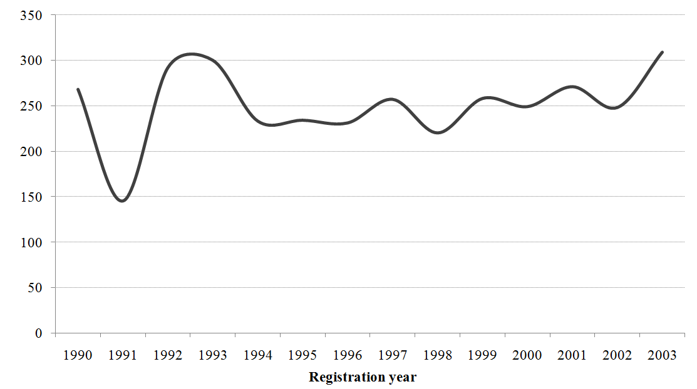
Figure A.2. Trademark registrations by time to issuance
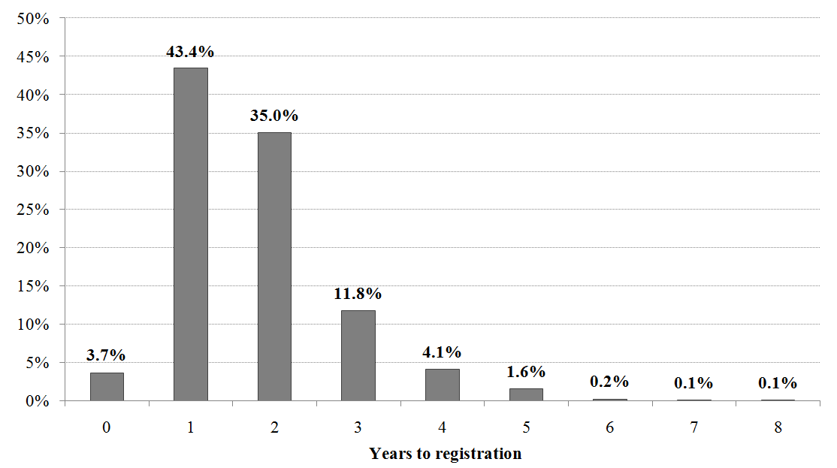
Note: time to issuance is calculated as the difference between registration and application years.

Figure A.3. Trademark registrations by age (at filing)
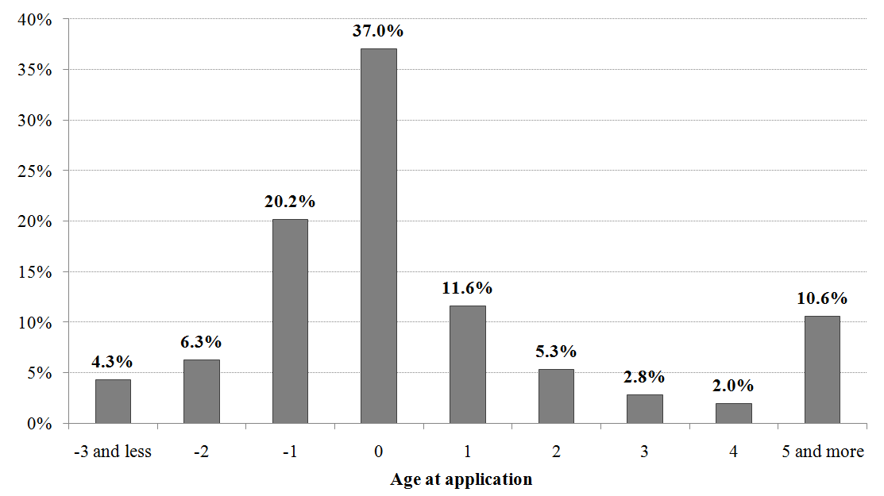
Note: trademark age (at filing) is calculated as the difference between the application year and the year in which the mark was first used in commerce.
Figure A.4. Trademark registrations by the number of product classes
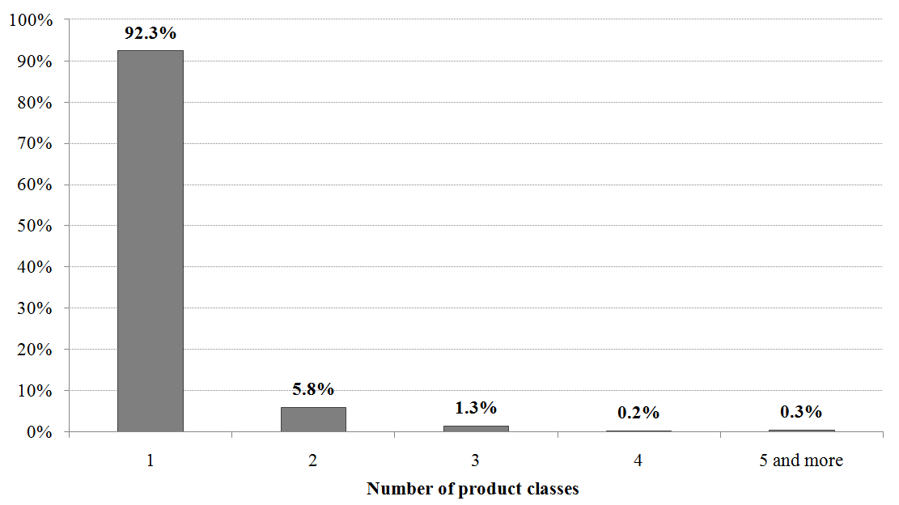
Note: trademark breadth is calculated as the number of classes covered by the mark.

Figure A.5. Trademark registrations by family type
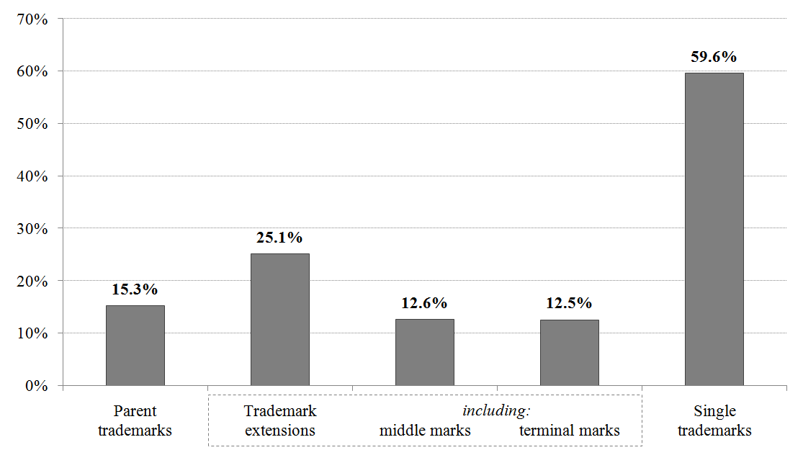
Note: parent trademarks are those with received citations only; trademark extensions are those with given citations; middle marks have both given and received citations; terminal marks have only given citations; and single trademarks are those with neither given nor received citations.
Figure A.6. Trademark registrations by text and depiction
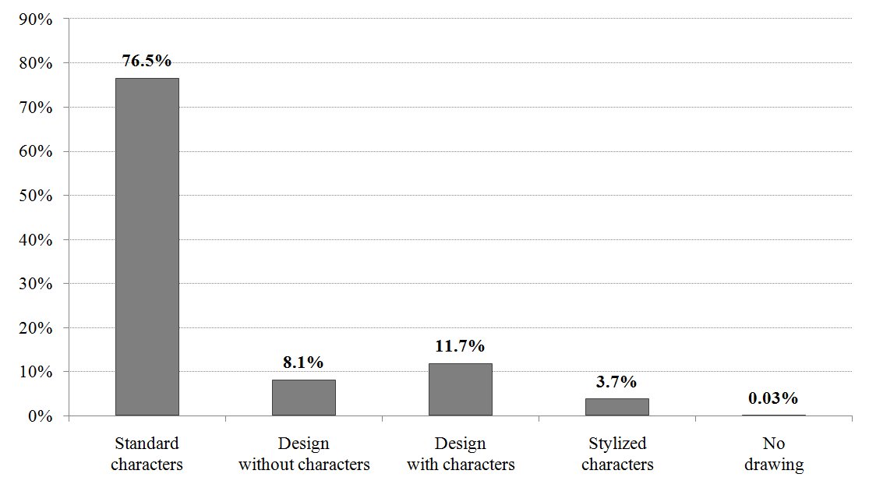
Note: the drawing code for standard characters starts with 1; for design without characters – with 2; for design with characters – with 3; for stylised characters – with 5; and for no drawing – with 6.

Appendix B. Description of variables
Table B.1. Description of study variables
Variable name | Definition
Dependent variables
Trademark registration | A dummy variable that takes the value of one if the mark was registered, and zero otherwise.
Trademark maintenance | A dummy variable that takes the value of one if the mark was maintained after seven years from the registration date, and zero otherwise.
Trademark renewal | A dummy variable that takes the value of one if the mark was renewed after ten years from the registration date, and zero otherwise.
Independent variables
Trademark age | The difference between the event date (registration, maintenance, or renewal) and the date when the mark was first used in commerce.
Trademark extension | A dummy variable that takes the value of one if the mark gives at least one citation to other marks, and zero otherwise.
Parent trademark | A dummy variable that takes the value of one if the mark only receives citations from other marks, but does not give citations to other marks, and zero otherwise.
Trademark breadth | The number of unique NICE classes covered by the mark.
Corporate trademark | A dummy variable that takes the value of one if the mark contains elements that are equal to or an abbreviation of the owner's name, and zero otherwise.
Brand-awareness trademark | A dummy variable that takes the value of one if the mark contains standard character drawings, and zero otherwise.
Service mark | A dummy variable that takes the value of one if the mark is labelled as a service mark, and zero otherwise.
Intent-to-use legal basis for filing | A dummy variable that takes the value of one if the mark was filed on the intent-to-use legal basis, and zero otherwise.
Received oppositions | A dummy variable that takes the value of one if the mark had an opposition first instituted and then sustained or dismissed, and zero otherwise.
Acquired distinctiveness | A dummy variable that takes the value of one if the mark acquired "secondary meaning" (full or partial), and zero otherwise.
Acknowledged incontestability | A dummy variable that takes the value of one if the mark received an approval concerning its incontestability, and zero otherwise.
Control variables
Company size | The natural logarithm of the total number of employees: ln(EMP).
Book leverage | The ratio of long-term debt plus current liabilities to total assets: (DLTT + DLC)/AT.
Tobin's q | The sum of total assets plus the difference between the market and the book value of equity divided by total assets: (AT + CSHO * PRCC_F – CEQ)/AT.
R&D intensity | The ration of R&D spending to total assets: XRD/AT.
Advertising intensity | The ration of advertising spending to sales: XAD/SALE.
Note: I used (i) the USPTO Case Files dataset (2015 edition) for trademark statistics; and (ii) the Standard & Poor's Compustat North America dataset for firm-level controls.

Table B.2. Description of the mnemonics used for the construction of study variables
Variable name | Mnemonic(s) | Source
Dependent variables
Trademark registration | REGISTRATION_NO is not NULL and  REGISTRATION_DT is not NULL | USPTO Case Files dataset  (2015 edition)
Trademark maintenance | REG_CANCEL_DT = 0 or  REG_CANCEL_DT – REGISTRATION_DT > 7
Trademark renewal | RENEWAL_DT > 0
Independent variables
Trademark age | event date (registration, maintenance, renewal) – FIRST_USE_COM_DT | USPTO Case Files dataset  (2015 edition)
Trademark extension | at least one citation given  for a given SERIAL_NO (table "prior_mark")
Parent trademark | at least one citation received; no citations given  for a given SERIAL_NO (table "prior_mark")
Trademark breadth | count distinct CLASS_PRIMARY_CD
Corporate trademark | MARK_ID_CHAR contains the owner's name or its abbreviation
Brand-awareness trademark | MARK_DRAW_CD = '1000'
Service mark | SERV_MARK_IN = 1
Intent-to-use legal basis for filing | LB_ITU_FILE_IN = 1 | USPTO Case Files dataset  (2015 edition)
Received oppositions | EVENT_CD = 'OP.I' or EVENT_CD = 'OP.S' or EVENT_CD = 'OP.D'
Acquired distinctiveness | ACQ_DIST_IN = 1 or  ACQ_DIST_PART_IN = 1
Acknowledged incontestability | INCONTEST_ACK_IN = 1
Control variables
Company size | ln(EMP) | Standard & Poor's Compustat North America dataset
Book leverage | (DLTT + DLC)/AT
Tobin's q | (AT + CSHO * PRCC_F – CEQ)/AT
R&D intensity | XRD/AT
Advertising intensity | XAD/SALE
Note: the mnemonics for the USPTO Case Files dataset are based on the dataset's description, which is available at https://www.uspto.gov/sites/default/files/ip/officechiefecon/trademark_case_files_appendix_i.pdf.

Appendix C. Robustness checks
Table C.1. Trademark characteristics and the probability of trademark registration:
Alternative estimation methods
Independent variables | Trademark registration
 | PRBT_ROB | LGT_ROB | PRBT_CLU | PRBT_FFE
Trademark age _{i,j,t} | 0.017** | 0.036** | 0.017*** | 0.022***
 | (0.006) | (0.013) | (0.005) | (0.007)
Trademark extension _{i,j} | - | - | - | -
Parent trademark _{i,j} | - | - | - | -
Trademark breadth _{i,j} | -0.003 | -0.015 | -0.003 | -0.064†
 | (0.034) | (0.058) | (0.051) | (0.036)
Corporate trademark _{i,j} | 0.595** | 0.924** | 0.595** | 1.067***
 | (0.200) | (0.360) | (0.206) | (0.257)
Brand-awareness trademark _{i,j} | -0.409*** | -0.725*** | -0.409*** | -0.346***
 | (0.047) | (0.080) | (0.090) | (0.048)
Service mark _{i,j} | 0.131* | 0.244* | 0.131 | 0.196***
 | (0.057) | (0.098) | (0.105) | (0.060)
Intent-to-use legal basis for filing _{i,j} | -1.465*** | -2.492*** | -1.465*** | -1.373***
 | (0.050) | (0.094) | (0.086) | (0.055)
Received oppositions _{i,j} | -0.682*** | -1.220*** | -0.682*** | -0.793***
 | (0.122) | (0.237) | (0.132) | (0.131)
Acquired distinctiveness _{i,j} | 0.271 | 0.575 | 0.271 | 0.154
 | (0.214) | (0.400) | (0.213) | (0.209)
Acknowledged incontestability _{i,j} | - | - | - | -
Firm controls | Yes | Yes | Yes | Yes
Firm fixed effects | No | No | No | Yes
Year fixed effects | Yes | Yes | Yes | Yes
Number of observations | 8,911 | 8,911 | 8,911 | 8,781
Number of companies | 94 | 94 | 94 | 82
Log likelihood | -4,299.9 | -4,296.5 | -4,299.9 | -3,962.5
Pseudo R² | 0.261 | 0.262 | 0.261 | 0.311
† 10% significance; * 5% significance; ** 1% significance; *** 0.1% significance.
The table shows the estimation results of different model specifications for the registration stage of the trademark lifecycle. The dependent variable in each case is a dummy variable that takes the value of one if the mark was registered, and zero otherwise. PRBT_ROB is a random effects probit model with standard errors corrected for heteroskedasticity by using the White-Huber method (the basis model). LGT_ROB is a random effects logit model with standard errors corrected for heteroskedasticity by using the White-Huber method. PRBT_CLU is a random effects probit model with standard errors clustered at the firm level. PRBT_FFE is a fixed effects probit model with standard errors corrected for heteroskedasticity by using the White-Huber method. Standard errors are in italics. Intercepts are included but not reported. Sources and variable definitions are given in Table B.1 in Online Appendix B.

Table C.2. Trademark characteristics and the probability of trademark maintenance:
Alternative estimation methods
Independent variables | Trademark maintenance
 | PRBT_ROB | LGT_ROB | PRBT_CLU | PRBT_FFE | PRBT_HEC
Trademark age _{i,j,t} | 0.021*** | 0.038*** | 0.021*** | 0.018*** | 0.021***
 | (0.005) | (0.011) | (0.005) | (0.005) | (0.005)
Trademark extension _{i,j} | 0.342*** | 0.557*** | 0.342*** | 0.415*** | 0.339***
 | (0.054) | (0.088) | (0.060) | (0.056) | (0.054)
Parent trademark _{i,j} | 0.692*** | 1.126*** | 0.692*** | 0.740*** | 0.695***
 | (0.065) | (0.108) | (0.062) | (0.068) | (0.065)
Trademark breadth _{i,j} | -0.019 | -0.036 | -0.019 | -0.011 | -0.021
 | (0.049) | (0.081) | (0.057) | (0.052) | (0.049)
Corporate trademark _{i,j} | 0.712*** | 1.299** | 0.712*** | 1.179*** | 0.728***
 | (0.215) | (0.410) | (0.219) | (0.277) | (0.223)
Brand-awareness trademark _{i,j} | 0.123* | 0.203* | 0.123† | 0.125* | 0.123†
 | (0.053) | (0.087) | (0.064) | (0.056) | (0.070)
Service mark _{i,j} | -0.400*** | -0.659*** | -0.400*** | -0.468*** | -0.408***
 | (0.070) | (0.115) | (0.076) | (0.076) | (0.073)
Intent-to-use legal basis for filing _{i,j} | 0.055 | 0.095 | 0.055 | 0.071 | 0.039
 | (0.052) | (0.086) | (0.056) | (0.055) | (0.180)
Received oppositions _{i,j} | 0.573* | 0.989* | 0.573** | 0.539* | 0.731**
 | (0.230) | (0.389) | (0.208) | (0.216) | (0.249)
Acquired distinctiveness _{i,j} | 0.014 | 0.005 | 0.014 | -0.036 | 0.019
 | (0.153) | (0.254) | (0.195) | (0.160) | (0.156)
Acknowledged incontestability _{i,j} | - | - | - | - | -
Firm controls | Yes | Yes | Yes | Yes | Yes
Firm fixed effects | No | No | No | Yes | No
Year fixed effects | Yes | Yes | Yes | Yes | Yes
Number of observations | 3,515 | 3,515 | 3,515 | 3,430 | 3,493
Number of companies | 88 | 88 | 88 | 65 | 94
Log (pseudo)likelihood | -2,250.0 | -2,248.5 | -2,250.0 | -2,124.9 | -6,537.4
Pseudo R² | 0.073 | 0.074 | 0.073 | 0.104 | -
† 10% significance; * 5% significance; ** 1% significance; *** 0.1% significance.
The table shows the estimation results of different model specifications for the maintenance stage of the trademark lifecycle. The dependent variable in each case is a dummy variable that takes the value of one if the mark was maintained after six years from the registration date, and zero otherwise. PRBT_ROB is a random effects probit model with standard errors corrected for heteroskedasticity by using the White-Huber method (the basis model). LGT_ROB is a random effects logit model with standard errors corrected for heteroskedasticity by using the White-Huber method. PRBT_CLU is a random effects probit model with standard errors clustered at the firm level. PRBT_FFE is a fixed effects probit model with standard errors corrected for heteroskedasticity by using the White-Huber method. PRBT_HEC is a random effects probit model with sample selection and with standard errors corrected for heteroskedasticity by using the White-Huber method (the second stage is reported; the first stage is similar to PRBT_ROB in Table C.1). Standard errors are in italics. Intercepts are included but not reported. Sources and variable definitions are given in Table B.1 in Online Appendix B.

Table C.3. Trademark characteristics and the probability of trademark renewal:
Alternative estimation methods
Independent variables | Trademark renewal
 | PRBT_ROB | LGT_ROB | PRBT_CLU | PRBT_FFE | PRBT_HEC
Trademark age _{i,j,t} | 0.004 | 0.006 | 0.004† | 0.004 | 0.000
 | (0.003) | (0.006) | (0.002) | (0.004) | (0.004)
Trademark extension _{i,j} | -0.013 | -0.018 | -0.013 | 0.062 | -0.102
 | (0.080) | (0.134) | (0.065) | (0.085) | (0.084)
Parent trademark _{i,j} | 0.367*** | 0.612*** | 0.367*** | 0.414*** | 0.178
 | (0.091) | (0.157) | (0.077) | (0.099) | (0.120)
Trademark breadth _{i,j} | -0.077 | -0.129 | -0.077 | -0.080 | -0.064
 | (0.064) | (0.108) | (0.083) | (0.074) | (0.058)
Corporate trademark _{i,j} | 0.821*** | 1.393*** | 0.821*** | 1.133** | 0.659**
 | (0.235) | (0.428) | (0.222) | (0.368) | (0.235)
Brand-awareness trademark _{i,j} | 0.292*** | 0.505*** | 0.292*** | 0.326*** | 0.234**
 | (0.082) | (0.137) | (0.081) | (0.088) | (0.083)
Service mark _{i,j} | -0.515*** | -0.857*** | -0.515*** | -0.490*** | -0.380**
 | (0.116) | (0.192) | (0.100) | (0.125) | (0.128)
Intent-to-use legal basis for filing _{i,j} | -0.089 | -0.164 | -0.089 | -0.055 | -0.089
 | (0.078) | (0.133) | (0.097) | (0.084) | (0.075)
Received oppositions _{i,j} | -0.090 | -0.174 | -0.090 | -0.191 | -0.208
 | (0.239) | (0.405) | (0.248) | (0.252) | (0.233)
Acquired distinctiveness _{i,j} | 0.136 | 0.233 | 0.136 | 0.112 | 0.118
 | (0.215) | (0.361) | (0.186) | (0.211) | (0.207)
Acknowledged incontestability _{i,j} | 0.747*** | 1.234*** | 0.747*** | 0.651*** | 0.701***
 | (0.126) | (0.213) | (0.134) | (0.132) | (0.128)
Firm controls | Yes | Yes | Yes | Yes | Yes
Firm fixed effects | No | No | No | Yes | No
Year fixed effects | Yes | Yes | Yes | Yes | Yes
Number of observations | 1,738 | 1,738 | 1,738 | 1,647 | 1,738
Number of companies | 77 | 77 | 77 | 77 | 88
Log (pseudo)likelihood | -955.1 | -955.6 | -955.1 | -893.0 | -3,113.2
Pseudo R² | 0.092 | 0.092 | 0.092 | 0.121 | -
† 10% significance; * 5% significance; ** 1% significance; *** 0.1% significance.
The table shows the estimation results of different model specifications for the renewal stage of the trademark lifecycle. The dependent variable in each case is a dummy variable that takes the value of one if the mark was renewed after ten years from the registration date, and zero otherwise. PRBT_ROB is a random effects probit model with standard errors corrected for heteroskedasticity by using the White-Huber method (the basis model). LGT_ROB is a random effects logit model with standard errors corrected for heteroskedasticity by using the White-Huber method. PRBT_CLU is a random effects probit model with standard errors clustered at the firm level. PRBT_FFE is a fixed effects probit model with standard errors corrected for heteroskedasticity by using the White-Huber method. PRBT_HEC is a random effects probit model with sample selection and with standard errors corrected for heteroskedasticity by using the White-Huber method (the second stage is reported; the first stage is similar to PRBT_ROB in Table C.2). Standard errors are in italics. Intercepts are included but not reported. Sources and variable definitions are given in Table B.1 in Online Appendix B.

This differentiates trademarks from, for example, patents: since novelty is among the key criteria for a patent to be granted, it is easier to draw a link between a particular patent and the underlying technological innovation. In contrast, trademarks can be registered for any good or service, be it novel or not; hence, additional analysis is often necessary to detect innovation-related trademarks (e.g., Flikkema et al., 2014; 2019; Seip et al., 2018).
The focus on the U.S. is motivated by the availability of detailed trademark statistics. Unlike other intellectual property offices, the U.S. Patent and Trademark Office (USPTO) recently released its administrative trademark data in a format convenient for research (see Graham et al., 2013). These data represent a comprehensive account of trademarking in the U.S. for many decades, including a detailed depiction of the prosecution process.
See Section 4.1 for more details on trademarking in the pharmaceutical sector.
See Sandner and Block (2011) for a comparison between patents and trademarks, as well as how the studies on patent value indicators can inform empirical trademark research.
Certain elements of trademark and related intellectual property law vary across countries. Given the empirical context of this study (see Section 4), its theoretical part is devoted to the U.S. trademark system; thus, U.S. law is hereinafter referenced and reviewed.
This is in contrast to patents and copyrights – their protection is guaranteed by the U.S. Constitution. At the same time, trademark protection at the federal level is governed by the Trademark Act of 1946, also known as the Lanham Act. The act not only establishes a set of rules on which the federal trademark registration system has to base itself, but also supplements common law with more precise definitions (Cohen, 1986).
The Trademark Law Revision Act of 1988 expanded the grounds on which trademark registration could be granted. More specifically, it introduced a provision that, along with actual commercial use, a trademark may be eligible for registration also when the applicant can demonstrate a bona fide intent to use it in commerce.
A special class of so-called famous marks was introduced by the Federal Trademark Dilution Act of 1995, which created a federal cause of action to prevent unauthorised use, trading upon the goodwill, and dilution of the distinctive quality of such marks. This act, though, has been largely replaced by the Trademark Dilution Revision Act of 2006.
For more details on this classification, see Pavitt (1984).
This approach is consistent with Bosworth's (1973) proposition that the number of times a patent is renewed should reflect the commercial importance of the associated invention. The fact that patent and trademark renewals are not automatic (and so the owner has to spend both time and money on making the renewal) further supports this proposition. In the patent literature, this approach was more recently adopted by Bessen (2008).
Filing a one-class trademark application costs USD 400. In addition, USD 125 must be paid to maintain the registration after the six-year period, and USD 425 to renew it after each successive ten-year period (hereinafter, all USPTO processing and service fees are given for electronic filings as of August, 2018).
It should be noted that economists tend to view trademarks as a means of product differentiation. In his classical work, Chamberlin (1933) argues that trademark protection gives a producer an opportunity to use advertising and other marketing methods to foster product differentiation. There are also more recent works that refer to trademarks in the product differentiation context, including some implications for manufacturing companies (see Cecere et al., 2015; Crass and Schwiebacher, 2017; Costa and Mendonça, 2019).
Since 1973, the USPTO has been using the International Classification of Goods and Services adopted under the NICE Agreement.
See Fink et al. (2018:341) for an analysis of trademark squatting – "a situation in which a company or individual registers a trademark that protects a good, service, or trading name of another company".
As Klieger (1996:828) shows, there are two types of trademark dilution – dilution by blurring (which "refers to dispersion of consumers' association of a particular trademark with a particular product or service"), and dilution by tarnishment (in this case, the quality representation function of a trademark is tarnished through negative or unsavoury associations).
Graham et al. (2013) note that trademark opposition is a very rare event, with only about 3% of all published applications being subject to opposition proceedings; of those, about 55% were subsequently registered.
Moreover, by engaging in the opposition process (instead of settling the dispute or just abandoning the mark), applicants thereby agree to incur additional costs that can also influence trademark valuation.
Filing a Section 15 affidavit of incontestability (15 U.S.C. §1065) costs USD 200 per class.
I adjusted all monetary variables to constant 2009 U.S. dollars by using the GDP deflator provided by the U.S. Bureau of Economic Analysis.
I use the owner at application name to identify trademark owners for trademark applications; in turn, the owner at registration is used to identify trademark owners for trademark registrations, maintenances, and renewals.
To ensure comparability, non-registered applications that were field only in the period between 1990 and 2003 were added to the final panel.
See Table B.1 and Table B.2 in Online Appendix B for the description of study variables and the mnemonics used to calculate them, respectively.
I have chosen this threshold to account for the fact that the effective period often exceeds six years due to a variety of reasons, including the six-month grace period granted to mark owners for filing corresponding declarations (Graham et al., 2013).
Although this is a common way to determine trademark breadth, it needs pointing out that "to expand protection of the mark for use on other products, the owner must apply for a new registration of the same mark identifying the additional goods and services" (Graham et al., 2013:13). Therefore, several single-class trademarks will be registered, thus diluting the actual breadth of the original mark.
I refer here to the probability of trademark registration. However, the probability of trademark maintenance or renewal can be specified in a similar manner.
A similar approach was used to derive the probability model of trademark renewal.
It should be noted that trademark age and trademark extensions have no statistically significant association with the probability of trademark renewal.

